THE ACCURACY OF ULTRASOUND-GUIDED VACUUM-ASSISTED
FINE-NEEDLE ASPIRATION FOR DIAGNOSIS AND MANAGEMENT OF BI-RADS 4 LESION
Panida Wongsansuk*
Somchanin Pipatpajong*
*Division of Diagnostic Radiology, Department of Radiology, Faculty of Medicine, Chulalongkorn University

ABSTRACT
Background : BI-RADS 4 lesion is in the category of suspicion for malignancy which has to be managed with core needle biopsy as specified in the standard guideline. Nonetheless, at King Chulalongkorn Memorial Hospital, an ultrasound-guided vacuum-assisted fine-needle aspiration (FNA) is performed in some cases of BI-RADS 4 lesion because it has been considered a simple and cost-effective tool for managing breast lesion in previous study.
Objectives : The purpose of this study is to evaluate the accuracy of an ultrasound-guided vacuum-assisted fine-needle aspiration in the diagnosis and management of BI-RADS 4 lesion.
Materials and Methods : A retrospective review was conducted on 251 female patients with BI-RADS 4 lesion who underwent an ultrasound-guided vacuum-assisted FNA, together with a subsequent procedure of either surgical biopsy or follow-up imaging for at least 2 years at King Chulalongkorn Memorial Hospital from January 2011 to December 2013. The sensitivity, specificity, positive predictive value (PPV) and negative predictive value (NPV) for the study data were evaluated. Also, the underestimation rate of unsatisfactory samples (C1) was calculated.
Results : The sensitivity, specificity, PPV and NPV for ultrasound-guided vacuum-assisted FNA were 72.73% (95%CI: 67.22-78.24%), 98.07% (95%CI: 96.36-99.77%), 88.89% (95%CI: 85.0-92.78%) and 94.42% (95%CI: 91.58-97.26%) respectively. 16 patients with discordant lesions between FNA cytology and surgical pathology were found, 4 of whom (1.9%) were false positives and 12 of whom (27.3%) were false negatives. Among 71 patients with unsatisfactory samples (C1), 67 cases (94.4%) showed benign results, while 4 cases (5.6%) showed malignant results.
Conclusion : An ultrasound-guided vacuum-assisted FNA is a reliable diagnostic tool for BI-RADS 4 lesion. However, there are some limitations that may cause false negative, especially in the case of a very small lesion, an inexperienced performer along with other uncontrollable factors e.g. heterogeneity or type of a tumor. Therefore, patient should be properly selected to prevent an error.
Keywords : Fine-needle aspiration, BI-RADS 4, Accuracy

ความแม่นยำในการวินิจฉัยและจัดการรอยโรค BI-RADS 4 ในเต้านม
ด้วยวิธีการดูดเจาะเซลล์โดยใช้อุปกรณ์สุญญากาศ
พนิดา วงศ์แสนสุข
สมชนินท์ พิพัฒน์ผจง
หน่วยงานรังสีวินิจฉัย ภาควิชารังสีวิทยา คณะแพทยศาสตร์ จุฬาลงกรณ์มหาวิทยาลัย

เหตุผลของการทำวิจัย : รอยโรค BI-RADS 4 เป็นรอยโรคในกลุ่มที่มีความเสี่ยงจะเป็นเนื้องอกร้ายซึ่งจำเป็นต้องได้รับการตรวจชิ้นเนื้อเพิ่มเติมด้วยการใช้เข็มเจาะตัดเนื้อเยื่อ (Core Needle Biopsy) ตามแนวทางรักษามาตรฐาน อย่างไรก็ดี โรงพยาบาลจุฬาลงกรณ์ได้มีการตรวจด้วยวิธีการดูดเจาะเซลล์โดยใช้อุปกรณ์สุญญากาศ (Vacuum-Assisted Fine-Needle Aspiration) นอกเหนือไปจากแนวทางรักษามาตรฐานดังกล่าว เนื่องจากการศึกษาก่อนหน้านี้แสดงให้เห็นว่า การตรวจด้วยการดูดเจาะเซลล์ให้ผลที่แม่นยำ และมีความคุ้มค่าทางเศรษฐศาสตร์
วัตถุประสงค์ : เพื่อต้องการศึกษาความแม่นยำในการวินิจฉัยและจัดการรอยโรค BI-RADS 4 ในเต้านมด้วยวิธีการดูดเจาะเซลล์โดยใช้อุปกรณ์สุญญากาศ
วิธีการทำวิจัย : ทำการศึกษาในผู้ป่วยหญิงที่ได้รับการวินิจฉัยว่ามีรอยโรค BI-RADS 4 จากการตรวจ แมมโมแกรมและอัลตราซาวด์ในโรงพยาบาลจุฬาลงกรณ์ ระหว่างเดือนมกราคม 2555 ถึงเดือนธันวาคม 2557 ซึ่งผู้ป่วยเหล่านี้ล้วนจำเป็นต้องได้รับการตรวจด้วยการดูดเจาะเซลล์โดยใช้อุปกรณ์สุญญากาศ ตามด้วยการตัดชิ้นเนื้อออกมาตรวจ หรือมีการตรวจติดตามด้วยภาพทางรังสีวิทยาอย่างน้อย 2 ปี หลังจากนั้น จึงนำผลดังกล่าวมาวิเคราะห์ เพื่อหาความแม่นยำของการตรวจด้วยวิธีการดูดเจาะเซลล์โดยใช้อุปกรณ์สุญญากาศ นอกจากนี้ ได้เก็บข้อมูลเพิ่มเติมเพื่อศึกษาว่า กลุ่มที่ผลการตรวจทางเซลล์วิทยาระบุว่า เซลล์ไม่เพียงพอต่อการวินิจฉัย (C1; Inadequate cell) มีแนวโน้มที่จะเป็นเนื้องอกร้าย หรือเนื้องอกชนิดไม่ร้ายแรงมากกว่า
ผลการศึกษา : ความไวของการตรวจด้วยการดูดเจาะเซลล์โดยใช้อุปกรณ์สุญญากาศอยู่ที่ 72.73% (95%CI : 67.22-78.24%), ความจำเพาะของการตรวจ 98.7% (95%CI : 96.36-99.77%), ค่าทำนายผลบวก 88.89% (95%CI : 85.0-92.78%) และค่าทำนายผลลบ 94.42% (95%CI : 91.58-97.26%) มีรอยโรคที่ผลตรวจด้วยเซลล์วิทยา และผลชิ้นเนื้อไม่เป็นไปในทิศทางเดียวกันรวม 16 ราย โดยเป็นผลบวกลวง 4 ราย (1.9%) และผลลบลวง 12 ราย (27.3%)
ผู้ป่วยที่ผลการตรวจทางเซลล์วิทยาระบุว่า เซลล์ไม่เพียงพอต่อการวินิจฉัยมีทั้งหมด 71 ราย โดยมีแนวโน้มที่จะเป็นเนื้องอกชนิดไม่ร้ายแรงจำนวน 67 ราย หรือคิดเป็น 94.4%
สรุป : การตรวจด้วยวิธีการดูดเจาะเซลล์โดยใช้อุปกรณ์สุญญากาศเป็นวิธีการที่น่าเชื่อถือ ซึ่งสามารถนำมาใช้วินิจฉัย และจัดการรอยโรค BI-RADS 4 ได้ อย่างไรก็ดี วิธีการตรวจดังกล่าวยังมีข้อจำกัดที่อาจส่งผลให้เกิดผลลบลวงโดยเฉพาะในกรณีที่รอยโรคมีขนาดเล็ก ประสบการณ์ของผู้ตรวจไม่เพียงพอ รวมถึงชนิดและความหลากหลายของเซลล์ในเนื้องอก จึงควรมีการคัดเลือกผู้ป่วยอย่างเหมาะสม เพื่อป้องกันการเกิดความผิดพลาด
คำสำคัญ : การดูดเจาะเซลล์, BI-RADS 4, ความแม่นยำ

INTRODUCTION
Breast cancer is a major health burden and the most prevalent cancer suffered by women worldwide which causes the greatest number of cancer deaths in Thailand, Southeast Asia and throughout the world.
Since regular breast cancer screening program has been set up, the mortality rate from breast cancer is reduced. Afterwards, American College of Radiology (ACR) has created Breast Imaging Reporting and Data System (BI-RADS) to categorize radiographic findings into 5 classifications which illustrates the likelihood of cancer and a guideline for further management (Table 1).

BACKGROUND
BI-RADS 4 lesion is in the category of suspicion for malignancy which can be classified into 4A, 4B and 4C subcategories, depending on radiographic findings and needs for tissue diagnosis (Table 2).
According to the standard guideline of NCCN version 1.2017, BI-RADS 4 lesion has to be managed with core needle biopsy. Nevertheless, at King Chulalongkorn Memorial Hospital, the guideline for screening/diagnostic mammogram was established with an additional ultrasound (Diagram 1) adapted from the standard guideline. So, if the patient is diagnosed with BI-RADS 4 lesion after the screening/diagnostic mammogram, she will be examined by the ultrasound-guided fine-needle aspiration (FNA) with vacuum assistance or a core needle biopsy.
As the previous studies have shown that a fine-needle aspiration has been considered a simple and cost-effective tool for the diagnosis and management of a palpable breast mass with high accuracy, the purpose of this study is to evaluate the accuracy of an ultrasound-guided vacuum-assisted FNA in the diagnosis and management of BI-RADS 4 lesion at King Chulalongkorn Memorial Hospital.

MATERIALS and METHODS
A retrospective review through a computer database was performed on 312 patients who had both screening and diagnostic mammograms from January 2011 to December 2013 at the Outpatient Unit of King Chulalongkorn Memorial Hospital and were diagnosed with BI-RADS 4 lesion. The patients who underwent an ultrasound-guided vacuum-assisted FNA, together with a subsequent procedure of either surgical biopsy or follow-up imaging for at least 2 years were included in this study. On the contrary, the patients whose lesions were diagnosed with a benign cystic fluid by FNA or could not be seen on the ultrasound or those with inconclusive pathological results or lost to follow-up were excluded.
The data of cytological result from FNA and a surgical pathological result must be available in the Hospital Information System (HIS). Besides, radiographic data must be available in the Picture Archiving and Communicating System (PACS). In this regard, age; location of the lesion; size, shape and margin of the lesion; the subcategory of BI-RADS 4 (4A, 4B and 4C); cytological and surgical histopathological results of each patient were all recorded.
Fine-needle aspiration was performed twice for each lesion with a 10mL syringe and a 22G spinal needle under the ultrasound guidance (GE 2013) by a breast radiologist at the Outpatient Department. The skin was prepared with povidone-iodine solution and anesthetized with 2% lidocaine. The lesion was punctured and aspirated under negative pressure. If the fluid was obtained, the lesion would be aspirated until it disappeared. If the mass was partially solid or entirely solid, the needle would be advanced and would maintain negative pressure in various directions until it could yield an approximate volume of content. After that, the content were sprayed and smeared on the glass slide and immediately fixed in 95% alcohol. All slides were submitted to the Department of Pathology on the same day. The cytological results were categorized into 5 grades according to the recommendations of the National Cancer Institute (NCI) for the diagnosis of a breast aspiration cytology, ranging from insufficient materials (C1), benign (C2), atypical (C3), suspicious of malignancy (C4) to frankly malignant (C5) (Table3). The results of FNA cytology were classified as positive (C3-C5) and negative (C1-C2) adapted from Kanchanabat B. and Pisano E. D. In this respect, the mass with indeterminate cytological nature (C3) required other diagnostic procedure to minimize the underestimation.
The cytological specimens were evaluated by one pathologist. Descriptive statistics were used in this study. The histopathological results from surgical biopsies were set as the criterion standard. As for the lesion which did not undergo surgical excision, its benign state was inferred by the stability on the follow-up radiographic imaging for at least 2 years.
The cytological and histopathological data were applied in two by two tables and the test accuracy was evaluated by calculating the sensitivity, specificity, positive predictive value (PPV) and negative predictive value (NPV). The discordant findings between cytological data and the criterion standard (false-positive and false-negative data) were mentioned and discussed later. With regard to the unsatisfactory samples (C1), they were analyzed in the form of binary data as the percentage of benignancy or malignancy.

RESULTS
251 patients who matched the criteria were studied. They were in the age range 23 - 76: mean age of 49 years. Concerning BI-RADS 4 subcategories, 192 (76.5%) were BI-RADS 4A, 46 (18.3%) were BI-RADS 4B and 13 (5.2%) were BI-RADS 4C.
The cytological result from FNA showed that 215 patients (85.6%) had negative FNA results (C1 and C2), whereas 36 patients (14.4%) had positive or suspicious aspiration (C4 and C5). On this point, 203 cases were negative cytology with benign surgical pathology (true negative), while 32 cases were positive cytology with malignant surgical pathology (true positive). Thus, the accuracy of FNA for BI-RADS 4 lesion is 93.6% (Table 4).
Analysis for the criterion standard, there were 45 patients (18%) with malignant surgical pathology, 70 patients (28%) with benign surgical pathology and 136 patients (54%) with inferred benign lesion by the stability on the follow-up radiographic imaging for at least 2 years i.e. no progression was found in the radiographic findings during the 2-year follow-up study.
The diagnosis of malignant lesion by the ultrasound-guided vacuum-assisted FNA showed 72.73% sensitivity (95%CI: 67.22-78.24%), 98.07% specificity (95%CI: 96.36-99.77%), 88.89% positive predictive value (95%CI: 85.00-92.78%) and 94.42% negative predictive value (95%CI: 91.58-97.26%).
There were 16 patients with discordant lesions between FNA cytology and surgical pathology, 4 of whom were positive cytology with benign surgical pathology (false positive) and 12 of whom were negative cytology with malignant surgical pathology (false negative). In brief, the false-positive and false-negative rates were 1.9% and 27.3% respectively.
71 patients (28.3%) had inadequate cytology (C1), 67 of whom (94.4%) showed benign results from the surgical histology or the stability on the radiographic imaging for at least 2 years, whereas 4 of whom (5.6%) showed malignant results from the surgical histology. Out of 4 patients with malignant surgical histology, 2 of them had atypical ductal hyperplasia and the others had invasive mammary carcinoma.

DISCUSSION
Although current standard guideline for BI-RADS 4 lesion management is to perform a core needle biopsy, recent studies have proved that FNA is a high-accuracy tool in managing a palpable breast mass with simplicity and cost-effectiveness. For this reason, it may be suitable for developing countries.
This study has shown that ultrasound-guided vacuum-assisted FNA is a reliable diagnostic tool for BI-RADS 4 lesion as it has high accuracy, NPV and PPV. The fine-needle aspiration biopsy (FNAB) could detect 32 true malignant lesions from 36 suspected malignant lesions or 88.9% PPV and could detect 203 true benign lesions from 215 suspected benign lesions or 94.4% NPV.
From 16 patients with discordant lesions between FNA cytology and surgical pathology (Table 5), 4 false positives i.e. case no. 3, 14, 15 and 16 were found with details as follows. Firstly, the patient in case no. 3 had a result of suggestive ductal carcinoma in situ (DCIS) or papillary neoplasm from FNA cytology but the surgical pathology showed fibroadenomatous hyperplasia and adenosis. Secondly, the one in case no. 14 had a result suggestive of low-grade ductal carcinoma from FNA cytology but the surgical pathology showed fibroadenoma. Regarding the last 2 cases, they had results of C3 category showing suspicion for malignancy and presence of atypical ductal cells from FNA cytology but the surgical pathology showed foreign body granuloma and fibrocystic change respectively. Mendoza P. et al demonstrated that false-positive findings were commonly found in ductal hyperplasia or lobular hyperplasia. Although this type of error may bring about an unnecessary investigation, the incidence rate is quite low.
On the other hand, 12 patients with false-negative lesions were found and they should be concerned because these could result in missed or delayed diagnosis and treatment. On this detail, there were 4 cases of scant cell cytology, 3 cases of suggestive of intraductal papilloma/papillary neoplasm, 1 case of sclerosing lesion, 1 case of benign lesion such as fibroadenoma and 3 cases of benign breast lesion.
False negatives of the scant cell cases were probably caused by (1) poor sampling technique especially in a very small lesion (2) tumor with minimal atypia component, which was known to be the limitation of the FNA study.
With regard to the cases of intraductal papillary lesion, since there is an overlap of imaging patterns between benign intraductal papilloma and other potential papillary cancers, including intraductal papilloma with ADH, papillary ductal carcinoma in situ and invasive papillary carcinoma, the cases that radiographic features demonstrate suspicion for papillary lesions should be examined by core needle biopsy (CNB) instead of FNA because CNB can provide a larger specimen and can reduce the rate of inadequate or suspicious results(Figure 1). Likewise, the complex sclerosing lesion (CLS) or radial scar (RS) and benign radiological and histological entities are recommended to be examined by an excision due to the difficulty to differentiate them from carcinoma(Figure 2).
Regarding 4 cases of benign breast cytology, their radiographs were retrospectively reviewed and malignant features were found in most of them, such as irregular/angular margin, taller than wide appearance or posterior shadowing, which was discordant with the benign cytological results. Therefore, further tissue diagnosis was required (Figure 3).
With respect to 71 patients who had inadequate cytological results (C1), most of them, about 94.4% turned out to be benign from either surgical pathology or follow-up imaging for at least 2 years. However, 5.6% of this group showed malignant result which was to be concerned. As a consequence, triple assessment, including clinical breast examination, radiographic findings and pathological assessment, should be individually re-evaluated in the suspicious case to avoid missed or delayed treatment.
CONCLUSION
Current evidence from this study has proved that ultrasound-guided vacuum-assisted FNA is a reliable diagnostic tool for BI-RADS 4 lesion. With its high sensitivity and specificity, most benign and malignant breast lesions can be accurately diagnosed. Still, there are some limitations of the FNA study which may cause false negative, especially in the case of a very small lesion, an inexperienced performer along with other uncontrollable factors e.g. heterogeneity or type of a tumor. Thus, patient should be properly selected to prevent an error. As for the cases that radiographic features show suspicion for papillary lesions or they can be initially considered as intraductal papillary lesion by FNA should undergo CNB since it can provide a larger specimen and can reduce the rate of inadequate or suspicious results. On the subject of complex sclerosing lesion, it should be examined by wide excision, although the CNB result was negative, to exclude a sampling error or an inadequate sampling.
Inadequate samples (C1) are more likely to be benign (94.4%) than malignant (5.6%). Nevertheless, triple assessment should be individually re-evaluated in the suspicious case to prevent missed or delayed treatment.

REFERENCES
1. Rao AA, Feneis J, Lalonde C, Ojeda-Fournier H. A Pictorial Review of Changes in the BI-RADS Fifth Edition. RadioGraphics 2016;36:623-39.
2. National Comprehensive Cancer Network. Breast cancer screening and diagnosis version 1.2017- June 2, 2017 [Internet]. 2017 [cited 2017 Aug 11]. Available from: https://www.nccn.org/professionals/physician_gls/pdf/breast-screening.pdf.
3. Kanchanabat B, Kanchanapitak P, Thanapongsathorn W, Manomaiphiboon A. Fine-needle aspiration cytology for diagnosis and management of palpable breast mass. Aust N Z J Surg 2000;70:791-4.
4. Nagar S, Iacco A, Riggs T, Kestenberg W, Keidan R. An analysis of fine-needle aspiration versus core needle biopsy in clinically palpable breast lesions: a report on the predictive values and a cost comparison. Am J Surg 2012;204:193-8.
5. Yu YH, Wei W, Liu JL. Diagnostic value of fine-needle aspiration biopsy for breast mass: a systematic review and meta-analysis. BMC Cancer 2012;12:41.
6. Pisano ED, Fajardo LL, Caudry DJ, Sneige N, Frable WJ, Berg WA, et al. Fine-needle aspiration biopsy of nonpalpable breast lesions in a multicenter clinical trial: results from the radiologic diagnostic oncology group V. Radiology 2001;219:785-92.
7. Mendoza P, Lacambra M, Tan PH, Tse GM. Fine-needle aspiration Cytology of Breast: The Nonmalignant Categories. Pathology Reseasrch International 2011;2011:8.
8. Omi Y, Yamamoto T, Okamoto T, Nishikawa T, Shibata N. Fine-needle aspiration versus core needle biopsy in the diagnosis of the intraductal breast papillary lesions. World J Pathol 2013;6:64-70.
9. Nassar A, Conners AL, Celik B, Jenkins SM, Smith CY, Hieken TJ. Radial scar/Complex Sclerosing Lesions: A Clinicopathologic Correlation Study from a Single Institution. Ann Diagn Pathol 2015;19:24-8.

Table 1: BI-RADS assessment categories
Category |  | Management | Likelihood of cancer
0 | Need additional imaging and/or await prior examination | Recall for additional imaging and/or await prior examination | Not available
1 | Negative | Routine screening | Essentially 0%
2 | Benign | Routine screening | Essentially 0%
3 | Probably benign | Short interval-follow-up (6 month) or continued | >0% but ≤2%
4 | Suspicious | Tissue diagnosis | 4A: low suspicion for malignancy (>2% to 10%)  4B: moderate suspicion for malignancy (>10% to <50%)  4C: high suspicion foe malignancy (>50% to <95%)
5 | Highly suggestive of malignancy | Tissue diagnosis | ≥95%
6 | Known biopsy proven | Surgical excision when clinical appropriate | Not available

Table 2: BI-RADS 4 Classification system
Category | Likelihood of cancer | Findings
4A | Low suspicion for malignancy (>2% to≤10%) | - Partially circumscribed solid mass with US features suggestive of fibroadenoma - Palpable solitary complicated cyst - Probable abscess
4B | Moderate suspicion for malignancy (>10% to≤50%) | - A group of amorphous or fine pleomorphic calcifications - Non descript solid mass with indistinct margins
4C | High suspicious, but not classic for malignancy (>50% to <95% ) | - New group of fine linear calcifications - New indistinct, irregular solid mass

Table 3: Cytological category according to NCI
Category | Cytology results | Findings
C1 | Unsatisfactory/Inadequate | - Less than 6 epithelial group of 5-10 cell each - Broken slide, wrong labeled slide - Poorly prepared (Too thick - too vigorous smearing, prolonged air-drying, no fixation for pap stain; Poor staining-weak diluted staining solution  - Too bloody obscuring diagnostic cells - Completely necrotic - Poorly cellular - Contaminants: Ultrasound gel
C2 | Cells present all benign, no suspicious features | - Non-specific pattern - Specific : Mastitis/Abscess - Numerous neutrophils and histiocytes, granular background, scanty reactive ductal cell(open chromatin vesicular/central nuclei) Breast cyst - Background of amorphous material, degenerate cells and debris, foamy macrophages, ductal epithelial cell (often apocrine and balling-up), myoepithelial cell may not be seen(do not overcall aspirate as malignant) Fibroadenoma- Moderate to high cellularity, tight cohesive branching antler-horn or finger-like projections of epithelial cells, stromal fragments (metachromatic fibrillary matrix material) , need both and stromal components to be diagnostic, numerous bare bipolar nuclei, bordering and within epithelial clusters, may see few foam cells or apocrine cells, often mild nuclear atypia with prominent nucleoli, particularly in younger patients Fat Necrosis - usually not very cellular, fragments of degenerate necrotic adipocytes with loss of nuclear staining, ductal cells are generally scanty , dirty background , foamy macrophages with multinucleated giant cells , calcium may be seen
C3 | Cell suspicious but probably benign | - Loss of cohesion/dyscohesive ductal cell - High cellularity  - No/ rarely seen myoepithelial cells (bipolar naked nuclei)  - Single atypical cells or loosely sheets of atypical cells  - Enlarged, pleomorphism
C4 | Cells suspicious but probably malignant | - Ductal cells with nuclear enlargement and prominent nucleoli but are in large sheets with no single cells - Only a few malignant cells are present - Malignant cell intermixed with bare bipolar nuclei
C5 | Definite malignancy | - Unequivocal evidence of malignancy is present - Need to type whether carcinoma, lymphoma, sarcoma or melanoma

Table 4: Two-by-two table of the accuracy of FNA cytology
Gold standard
(Surgical histopathology/2-year imaging stable)
 |  | Malignant | Benign
FNA | Malignant (C3-C5) | 32 (A) | 4 (B)
FNA | Benign (C1-C2) | 12 (C) | 203 (D)
A = True malignant lesion, B = False positive, C = False negative, D = True benign lesion

No  Table 5: Discordant lesions | Type | BI-RADS | Radiographic findings | FNAC findings | Gold Standard findings
1 | C | 4C | A 1.6x1.4-cm ill-defined hypodense nodule at inner mid part of right breast (taller than wide, posterior acoustic shadow, indistinct margin) | No malignancy | IDC grade I/II, presence of cribiform DCIS
2 | C | 4C | A 0.8x1.0-cm ill-defined hypodense nodule with angulate margin in left upper mid part of left breast | Benign; Fibroadenoma | IDC of NOS grade II
3 | B | 4A | Slightly increased size of a 1.1x0.9x0.9-cm lobulated hypoechoic mass in RUIQ | Suggestive of ADH, DCIS or papillary neoplasm | Fibroadenomatous hyperplasia and adenosis
4 | C | 4B | A small stellate lesion at RUOQ, ultrasound showing focal shadowing area in RUOQ. Please consider wired localized wide excision even FNA is negative | Sclerosing lesion | IDC grade I and cribiform DCIS focus
5 | C | 4B | Increased size of a 0.5x1.3-cm well-defined lobulated hypoechoic nodule in LUOQ with new 0.8x0.6-cm ill-defined hypoechoic lesion with focal shadow at left central area | Benign proliferative breast disease or papillary neoplasm | Multifocal IDC grade II with LVI
6 | C | 4B | A 0.6x0.5-cm ill-defined hypoechoic lesion at RUOQ | Probably benign | Intermediate grade DCIS with comedonecrosis
7 | C | 4A | Increased size of a 1.2x0.8-cm lobulated hypoechoic lesion at right subareolar area with internal vascularity | Benign breast nodule | IDC grade II with fibroadenomatous change
8 | C | 4A | A 0.6x0.9-cm partially defined hypoechoic nodule with echogenic rim at right outer mid part | Scant cell | Early fibrocystic change with ADH
9 | C | 4A | A 0.4-cm ill-defined hypoechoic nodule at LUIQ | Scant cell | ADH
10 | C | 4C | A 0.6x0.8-cm ill-defined irregular hypoechoic nodule with echogenic rim at LUIQ | Suggestive of intraductal papilloma | Papillary lesion with area of invasive tumor
11 | C | 4A | A 0.7x1.2-cm well-defined lobulated hypoechoic mass at RUOQ | Scant cell | IDC grade II
12 | C | 4B | A well-defined lobulated cystic mass with internal solid component and increased vascularity at RUOQ, possible papilloma or papillary CA | Suggestive of intraductal papilloma | Encapsulated papillary carcinoma with IDC component
13 | C | 4C | A 0.6x0.7-cm ill-defined irregular hypoechoic lesion with taller than wide at RUOQ | Scant cell | Invasive mammary carcinoma
14 | B | 4A | A 0.5x0.2-cm irregular ill-defined hypoechoic nodule at RUIQ | Suggestive of low-grade ductal cancer | Fibroadenoma
15 | B | 4A | A 0.7x0.6x0.6-cm ill-defined hypoechoic nodule in RUIQ, adjacent to the surgical scar (Sclerosing fibroadenoma) | Suspicious malignant cell | Foreign body granuloma (suture)
16 | B | 4A | A 0.4x0.3-cm partially ill-defined hypoechoic nodule with posterior shadow at RLOQ | Presence of atypical ductal cell | Fibrocystic change

B - False positive lesion, C = False negative lesion, ADH = Atypical ductal hyperplasia,
IDC = Invasive ductal carcinoma, DCIS = Ductal carcinoma in situ, LVI = Lymphovascular invasion

Diagram1: Guideline for breast cancer screening in King Chulalongkorn Memorial Hospital
Screening/Diagnostic mammogram with additional ultrasound
ulultrasound
BI-RADS 4
Vacuum-assisted FNA under ultrasound guidance/ Core needle biopsy/ Surgical excision

C1 (Inadequate)
C2 (Benign)
C3 (Probably benign)
C4 (Suspicious of malignancy)
C5 (Malignancy)
F/U with mammogram every 6 months for 2 years
Mastectomy
Excisional biopsy

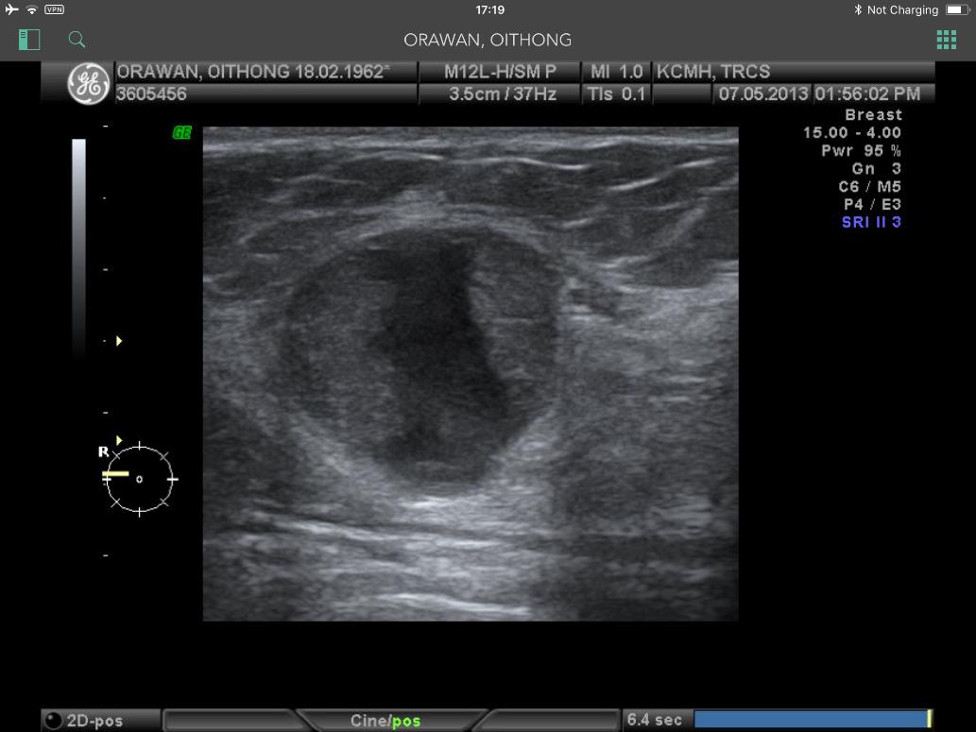
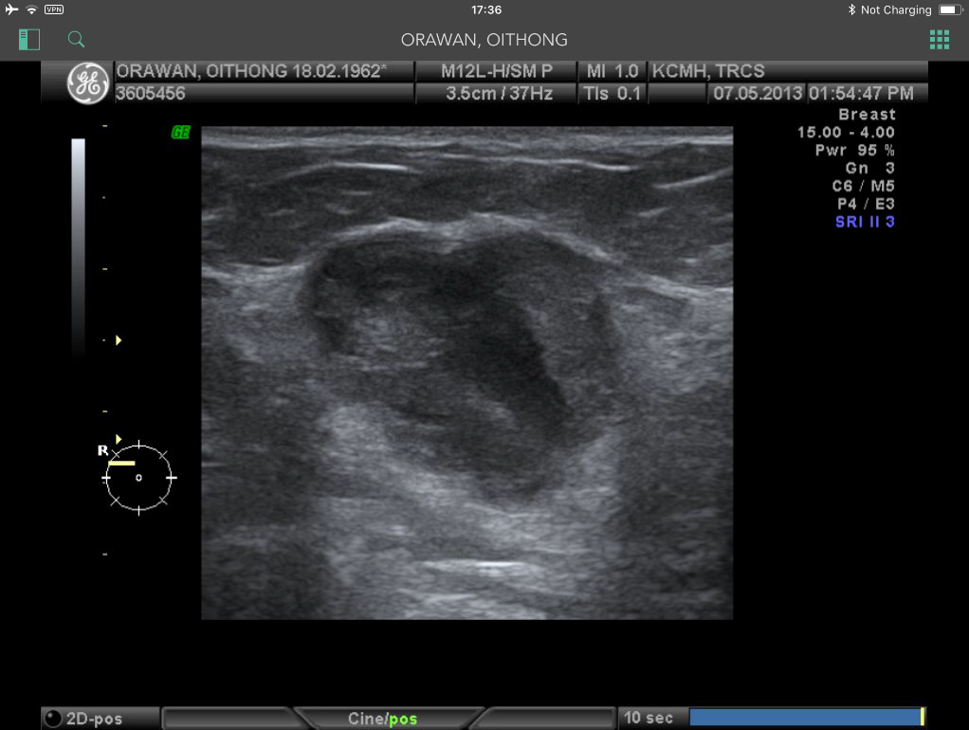
A
B

Figure 1: Discordant lesion - Intraductal papillary lesion
(A) and (B) An ultrasound of the right breast in two perpendicular views : A 4.2x3.9-cm well-defined lobulated cystic mass with internal solid component and increased vascularity (not shown) at RUOQ (BI-RADS 4b), possible papilloma or papillary cancer. The surgical pathology revealed papillary carcinoma with IDC component.

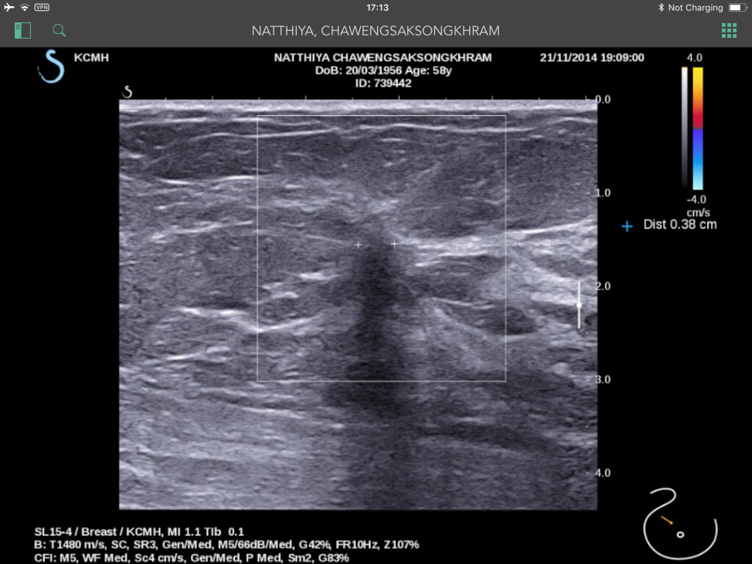
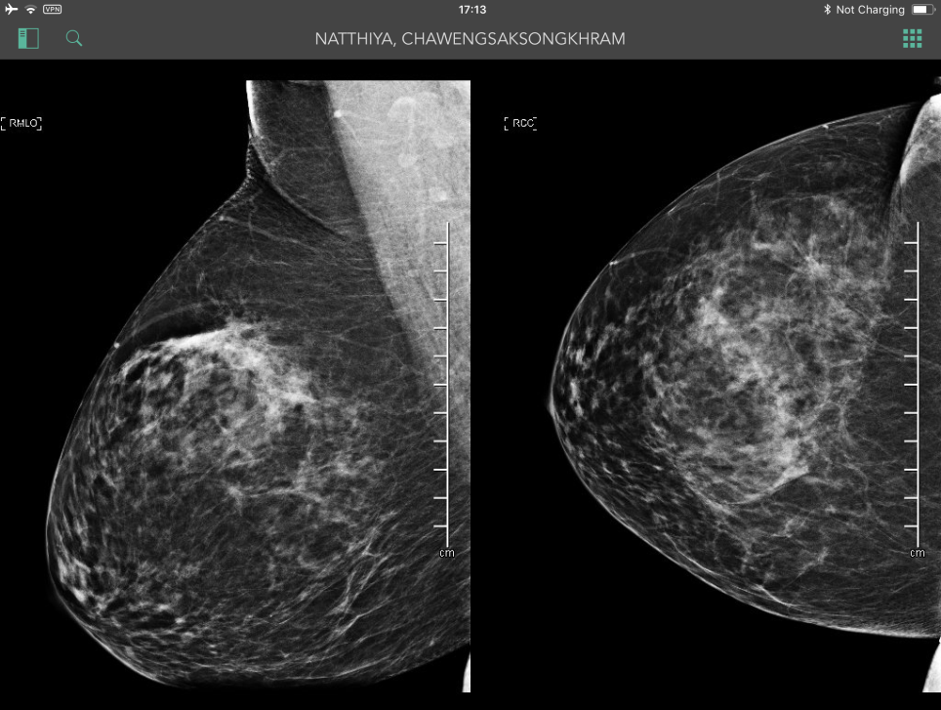
A
B

Figure 2 : Discordant lesion - Sclerosing lesion/Radial scar
A
(A) A mammogram in MLO and CC views; and (B) an ultrasound of the right: A 1.8x0.6-cm spiculate mass at RUOQ and the additional ultrasound was seen as an ill-defined mass with posterior shadow. The surgical pathology revealed IDC grade I and cribiform DCIS focus.

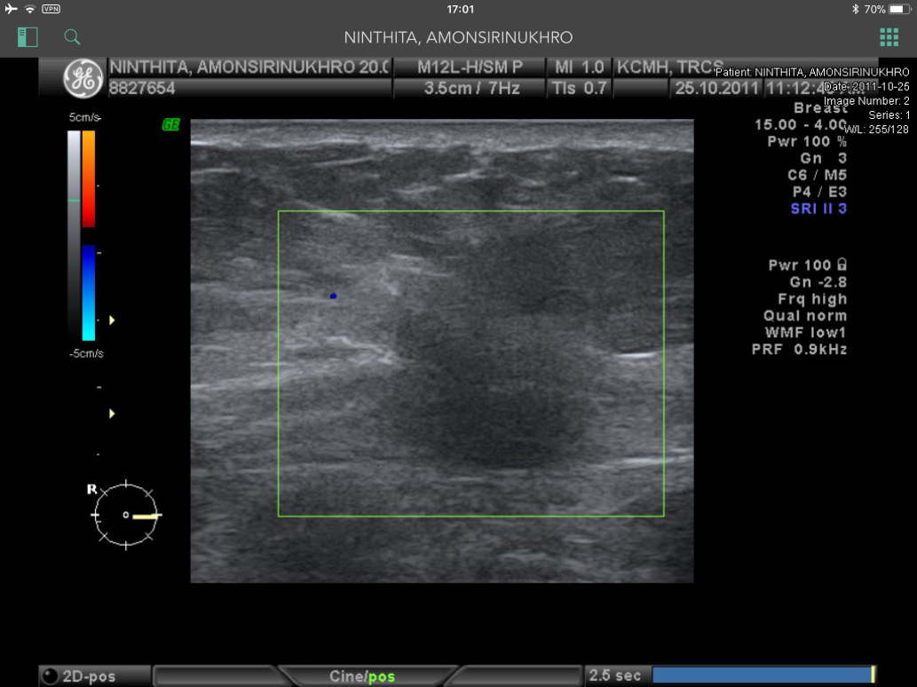
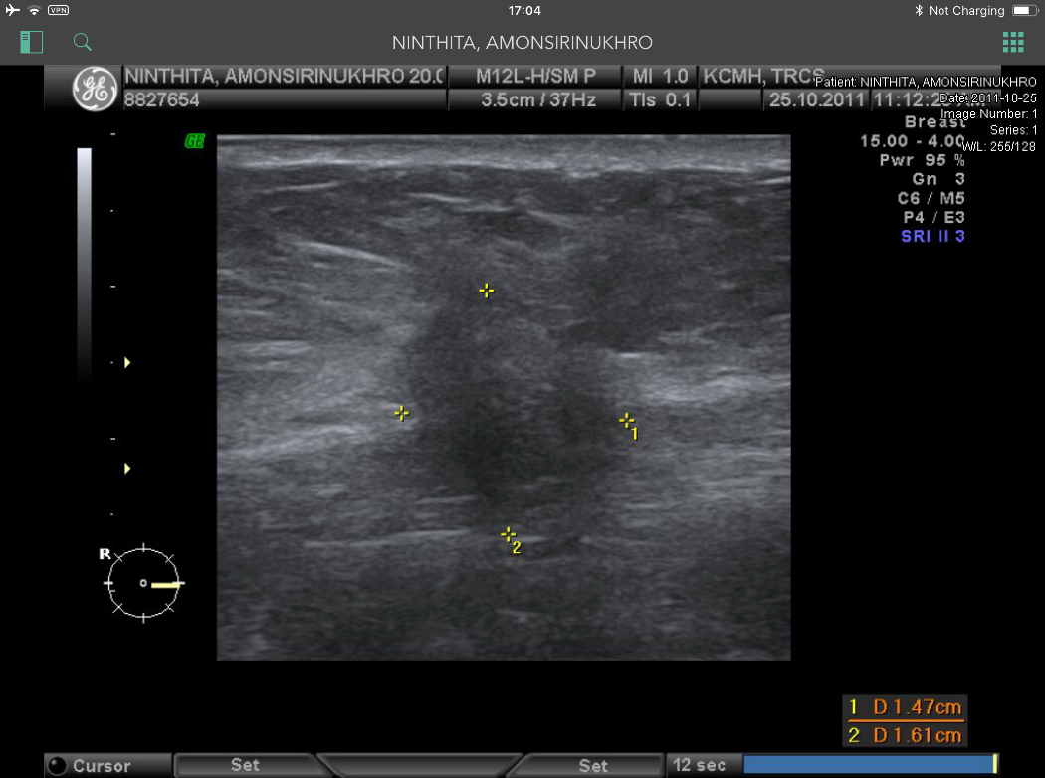
A
B

Figure 3: Discordant lesion - Malignant features
(A) An ultrasound of the right breast (B) with color doppler: A 1.6x1.4-cm ill-defined hypodense nodule at inner mid part of right breast with angular margin and taller than wide, no demonstrable internal vascularity. The FNA cytology was negative and the surgical pathology revealed IDC with cribiform DCIS, accounting for 10% of total tumor volume.

