Title Page
1. Mr. Phoomchai Engkananuwat
Department of Physical Therapy, Faculty of Allied Health Sciences, Chulalongkorn University, 154 Soi Chula 12, Rama I Road, Pathumwan, Bangkok 10330, Thailand
2. Asst. Prof. Rotsalai Kanlayanaphotporn
Department of Physical Therapy, Faculty of Allied Health Sciences, Chulalongkorn University, 154 Soi Chula 12, Rama I Road, Pathumwan, Bangkok 10330, Thailand
3. Assoc. Prof. Nithima Purepong
Carolina Asia Center, The University of North Carolina at Chapel Hill, NC 27599 USA.

Corresponding author:
Asst. Prof. Rotsalai Kanlayanaphotporn
Department of Physical Therapy, Faculty of Allied Health Sciences, Chulalongkorn University, 154 Soi Chula 12, Rama I Road, Pathumwan, Bangkok 10330, Thailand
E-mail address: rotsalai.k@chula.ac.th
Tel. 02-218-3767 ext. 205, 086-990-3775
Fax. 02-218-3767

Title Page
1. นายภูมิชัย อิงคนานุวัฒน์
ภาควิชากายภาพบำบัด คณะสหเวชศาสตร์ จุฬาลงกรณ์มหาวิทยาลัย
154 ซอยจุฬาฯ 12 ถนนพระราม 1 เขตปทุมวัน กรุงเทพฯ 10330 ประเทศไทย
2. ผศ. ดร. รสลัย กัลยาณพจน์พร
ภาควิชากายภาพบำบัด คณะสหเวชศาสตร์ จุฬาลงกรณ์มหาวิทยาลัย
154 ซอยจุฬาฯ 12 ถนนพระราม 1 เขตปทุมวัน กรุงเทพฯ 10330 ประเทศไทย
3. รศ. ดร. นิธิมา เพียวพงษ์
Carolina Asia Center, The University of North Carolina at Chapel Hill, NC 27599 USA.

Corresponding author:
ผศ. ดร. รสลัย กัลยาณพจน์พร
ภาควิชากายภาพบำบัด คณะสหเวชศาสตร์ จุฬาลงกรณ์มหาวิทยาลัย
154 ซอยจุฬาฯ 12 ถนนพระราม 1 เขตปทุมวัน กรุงเทพฯ 10330 ประเทศไทย
E-mail address: rotsalai.k@chula.ac.th
Tel. 02-218-3767 ext. 205, 086-990-3775
Fax. 02-218-3767

Effectiveness of the simultaneous stretching of the Achilles tendon and plantar fascia in individuals with plantar heel pain
Abstract
Background: Previous studies have shown that separate stretching of the Achilles tendon and the plantar fascia are effective interventions for treating patients with plantar heel pain. Since these two structures are anatomically connected, the simultaneous stretching of both structures may result in an improved outcome.
Objective: To evaluate the effects of the simultaneous stretching of the Achilles tendon and plantar fascia with the continuous passive stretching (CPS) instrument in patients with plantar heel pain.
Setting: Department of Physical Therapy, Faculty of Allied Health Sciences, Chulalongkorn University.
Study design: One-group pretest-posttest design.
Subjects: Fifteen participants aged 40-60 years with a history of plantar heel pain greater than 1 month.
Method: The participants were instructed to use the CPS instrument for 5 days per week for 4 consecutive weeks. Plantar heel pain at first step in the morning, average pain over the past 24 hours, pressure pain threshold, foot and ankle disability, passive ankle range of motion, and global perceived effect were taken before and after 4 weeks of treatment.
Results: After 4 weeks of stretching, the participants showed significant decreases in pain intensity (P < 0.001) as well as foot and ankle disability (P < 0.001) whereas there were significant increases in pressure pain threshold (P < 0.001) and ankle passive dorsiflexion range of motion (P < 0.001).
Conclusion: The simultaneous stretching of the Achilles tendon and plantar fascia via the CPS instrument is effective in alleviating symptoms in patients with plantar heel pain.
Keywords: Achilles tendon, plantar fascia, plantar heel pain, stretching.

ผลของการยืดเอ็นร้อยหวายและพังผืดฝ่าเท้าพร้อมกันในผู้ที่มีอาการปวดฝ่าเท้า
บทคัดย่อ
เหตุผลของการทำวิจัย: การยืดเอ็นร้อยหวายและพังผืดฝ่าเท้าเป็นวิธีในการรักษาอาการปวดฝ่าเท้า การยืดทั้งสองโครงสร้างพร้อมกัน อาจจะให้ผลการรักษาที่ดีขึ้น
เป้าหมาย: เพื่อทดสอบการยืดเอ็นร้อยหวายและพังผืดใต้ฝ่าเท้าพร้อมกันด้วยเครื่อง continuous passive stretching (CPS) ในผู้ป่วยที่มีอาการปวดฝ่าเท้า
สถานที่: ภาควิชากายภาพบำบัด คณะสหเวชศาสตร์ จุฬาลงกรณ์มหาวิทยาลัย
รูปแบบงานวิจัย: One-group pretest-posttest design
กลุ่มประชากร: ผู้ที่มีอาการปวดฝ่าเท้าอย่างน้อย 1 เดือน อายุ 40-60 ปี จำนวน 15 คน
วิธีการศึกษา: ผู้เข้าร่วมงานวิจัยได้รับคำแนะนำให้ใช้เครื่อง CPS เป็นเวลา 5 วันต่อสัปดาห์ ต่อเนื่องกัน 4 สัปดาห์ โดยวัดระดับความเจ็บปวดก้าวแรกของการลงน้ำหนักในตอนเช้า, ระดับความเจ็บปวดโดยเฉลี่ยตลอด 24 ชั่วโมงที่ผ่านมา, ค่าแรงกดที่เริ่มรู้สึกเจ็บ, ระดับความทุพพลภาพของเท้าและข้อเท้า, องศาการเคลื่อนไหวของข้อเท้า และการรับรู้โดยรวมต่อการรักษา ก่อนและหลังการรักษา 4 สัปดาห์
ผลการศึกษา: หลังการรักษาด้วยการยืด 4 สัปดาห์ พบมีการลดลงอย่างมีนัยสำคัญของระดับความเจ็บปวด (P < 0.001) และระดับความทุพพลภาพของเท้าและข้อเท้า (P < 0.001) ในขณะที่พบมีการเพิ่มขึ้นอย่างมีนัยสำคัญของค่าแรงกดที่เริ่มรู้สึกเจ็บ (P < 0.001) และองศาการเคลื่อนไหวของการกระดกข้อเท้าขึ้น (P < 0.001)
สรุปผลการศึกษา: การยืดเอ็นร้อยหวายและพังผืดใต้ฝ่าเท้าพร้อมกันด้วยเครื่อง CPS มีประสิทธิภาพช่วยบรรเทาอาการให้ผู้ป่วยที่มีอาการปวดฝ่าเท้าได้
คำสำคัญ: เอ็นร้อยหวาย, พังผืดฝ่าเท้า, อาการปวดฝ่าเท้า, การยืด
Introduction
Plantar heel pain is characterized by pain along the medial plantar aspect of the heel or at the insertion site of the plantar fascia at the medial tuberosity of the calcaneal bone.⁽¹⁻³⁾ Plantar heel pain accounts for approximately 11-15% of all foot pain and 33.4% of those complaining of chronic plantar heel pain.⁽⁴⁾ It commonly affects people between 40 and 60 years of age.⁽⁵⁾
Causes of plantar heel pain can be divided into intrinsic and extrinsic factors.^{(5, 6)} Intrinsic factors include advanced age, abnormal foot posture, being overweight, and the tightness of the Achilles tendon, while extrinsic factors include the use of poor footwear as well as the type and intensity of daily activity. Together with repetitive use of the foot, the plantar fascia is placed under mechanical overload. As a result, this may produce a microtear within the fascia which causes an inflammatory response and pain.
Several non-operative treatments have been proposed for plantar heel pain such as rest, therapeutic exercise, massage, physical modalities, therapeutic orthotic insoles, injections, and medications.^{(2, 7, 8)} Among these treatments, the stretching of tight calf and plantar tissues has been proven to be effective for relieving symptoms.⁽⁹⁾ Both the sustained and intermittent techniques of stretching the Achilles tendon were found to be equally effective in improving the pain and ankle range of motion as well as foot and ankle function.⁽¹⁰⁾ Pain is also lessened when adding trigger point manual therapy over gastrocnemius and soleus muscles to the stretching of the Achilles tendon.⁽¹¹⁾ However, one recent study has shown that stretching exercise specific to the plantar fascia is superior to the standard Achilles tendon stretching.⁽¹²⁾
Anatomically, the Achilles tendon and the plantar fascia are fascially connected.⁽¹³⁾ It is therefore plausible that the stretching of these structures simultaneously places more tension on the tissues than the isolated stretching of each structure and provides a better outcome. However, no research has been conducted to prove this notion. The purpose of this study was to evaluate the effects of the simultaneous stretching of the Achilles tendon and plantar fascia on pain and disability in patients with plantar heel pain.
Methods
Participants
The study protocol was approved by the Ethics Review Committee for Research Involving Human Research Subjects, Health Sciences Group, Chulalongkorn University (number 098.2/58). Participants aged 40-60 years with a history of plantar heel pain greater than 1 month were recruited. To be eligible for inclusion, the participants had to have localized pain on palpation at the medial plantar calcaneal region. The pain at the first step in the morning had to be greater than or equal to 4 out of 10 on the 11-point Numeric Pain Rating Scale (NPRS) which had to decrease with movement such as walking. Furthermore, the participants were requested to decline from the application of other treatments or medications during the study period. Exclusion criteria were as follows: individuals with red flags (i.e., tumor, rheumatoid arthritis, severe vascular disease, etc.), a history of fractures of lower extremities, prior surgery of lower extremities, neural problems in lower extremities, diabetes mellitus, and pregnancy.
The sample size was calculated based on the standard deviation of 2.2 points from a previous study⁽¹⁰⁾ and the magnitude of the minimum clinically significant difference of 2 points on 11-point NPRS.⁽¹⁴⁾ Configuration error and power were set at 0.05 and 0.80, respectively. A total sample size of 10 participants was therefore required for this study.
Materials
The CPS instrument (Figure 1), an innovative stretching instrument developed by our research team,⁽¹⁵⁾ was used in this study. The instrument was devised for simultaneously stretching the Achilles tendon and the plantar fascia by taking the benefits from the standard Achilles tendon stretching in weight bearing condition with less strain on a participant’s back. It consists of 2 wooden bases covered with a Bene-feet mat which is composed of many long flexible spikes with the shorter spikes located at the front and the back and the taller ones in the middle. Each wooden base is equipped with a goniometer and a motor that can move the base up and down independently for each foot in the range of 0-60 degrees ankle dorsiflexion at the speed of 0.8-1.3 degrees per second. This velocity aims to provide a gentle stretch to the Achilles tendon and the plantar fascia with a minimal risk of injury. When the participants stood on the CPS instrument, the Achilles tendon was stretched while several points in the plantar fascia were pressed and stretched thoroughly.
Outcome measures
Pain intensity
An 11-point NPRS⁽¹⁴⁾ was used for measuring pain at first step in the morning and the average pain at the medial plantar calcaneal region over the past 24 hours. On the scale, 0 represents no pain and 10 represents the worst pain imaginable.
Pressure pain threshold
A pressure algometer (JTech) with 1 cm² surface area was used to measure the pressure pain threshold at the tender point of the plantar fascia at the medial plantar calcaneal region. The instrument was found to be highly reliable with a Cronbach’s alpha of 0.94-0.98.⁽¹⁶⁾ The researcher gradually applied pressure through the pressure algometer over the tender point until the participant started to feel pain and the amount of pressure force shown on the screen was recorded. In this study, the tender point was defined as the point where the participant was unable to tolerate a pressure of more than 3 kg/cm² or where the pressure threshold was at least 2 kg/cm² lower than the asymptomatic side. Once the tender point was established, the pressure was then applied 3 times with 10-second intervals in between and the average data were used for analysis.

Ankle passive ranges of motion
Passive ankle dorsiflexion and plantar flexion were measured when the participants lay supine with the knees extended. A universal goniometer was aligned with a pivot point over lateral malleolus, a stationary arm parallel to the fibula bone, and a movable arm parallel to the fifth metatarsal bone. Then the participants’ ankle was passively dorsiflexed (the foot lifted up towards the shin) and plantarflexed (the foot moved down towards the bed) 3 times in each direction, and the average values were used for analysis.
Foot and ankle disability
The Thai version of the visual analogue scale foot and ankle questionnaire (VAS-FA) was used for assessing foot and ankle disability. It has been shown to be highly reliable with an intraclass correlation coefficient of 0.995 and the Cronbach’s alpha of 0.995.⁽¹⁷⁾ The questionnaire consists of 20 items.⁽¹⁸⁾ Four items relate to pain, 11 items to functional limitation, and 5 items to the quality of life due to impairment of the foot and ankle-related problems. Each question was scored 0-100 points by asking participants to draw an “X” along the scale of a 100-mm line based on individuals’ feeling for each question. Zero represents the most severe disability while 100 represents no disability. The total score for the VAS-FA ranges from 0-2,000 points. For analysis, the total score was divided by 20 so the final score would range from 0-100 points. The lower score the higher the foot and ankle disability.
Global perceived effect questionnaire
The global perceived effect questionnaire measures participants’ perceived change after the intervention.⁽¹⁹⁾ It consists of a 7-point scale ranging from 1 to 7 (1 = completely recovered, 2 = much improved, 3 = slightly improved, 4 = no change, 5 = slightly worsened, 6 = much worsened, and 7 = worse than ever).

Procedure
All participants received stretching using the CPS instrument. The baseline data which consisted of pain at the first step in the morning, average pain intensity over the past 24 hours, pressure pain threshold, ankle passive ranges of motion, and foot and ankle disability were measured by an assessor. Next, a physical therapist who was blinded to the participants’ baseline data asked the participants to step onto each wooden base of the CPS instrument which was initially set at 0 degrees dorsiflexion. The participants were instructed to keep their hips and knees straight. Then, the wooden base of the symptomatic side was raised up first until the participants started to feel tolerable tension in their Achilles tendon. Subsequently, the wooden base on the asymptomatic side was raised up to the same angle (Figure 2). The stretch was held for 20 seconds for 5 sets. A 20-second rest was allowed between sets in which the wooden bases were lowered to the initial 0 degree dorsiflexion. Then, the participants stepped off the CPS instrument and walked around for 10 minutes and returned for another 5 sets. All participants were required to attend the laboratory 5 days per week for 4 consecutive weeks. The same assessor examined average pain intensity over the past 24 hours at the end of each week. Pain at first step in the morning, pressure pain threshold, ankle passive ranges of motion, foot and ankle disability, and global perceived effect were measured at the end of the 4-week intervention period.
All participants were requested to continue their normal activities and avoid other forms of treatment while receiving the intervention. However, any received medications and other treatments were recorded.
Statistical analysis
SPSS 17 (SPSS, Chicago, IL) was used for statistical analysis. Means and standard deviations were calculated for each variable. A dependent t-test was used to test for the effects of the simultaneous stretching using the CPS instrument on pain at first step, pressure pain threshold, ankle passive ranges of motion, and foot and ankle disability between baseline and the end of the 4-week intervention period. The one-way repeated measures ANOVA were used to test for the effect of the simultaneous stretching on average pain intensity over the past 24 hours between baseline and at the end of each week. The Bonferonni Correction was used as post hoc analysis to identify the pair(s) that was responsible for the significant difference. P-value was set at < 0.05 for all statistical analyses.
Results
Fifteen participants took part in this study. The means (standard deviations) of participants’ clinical and demographic data at baseline are shown in Table 1. None of the participants reported any adverse effects due to the stretching technique. At the end of the 4-week intervention, a significant increase in pressure pain threshold and ankle passive dorsiflexion range of motion was demonstrated whereas there was a significant decrease in pain at first step in the morning as well as foot and ankle disability (P < 0.001) (Table 2).
The average pain intensity over the past 24 hours at the end of each treatment week decreased significantly from baseline (P < 0.05) (Figure 3). All participants reported positive responses on their global perceived effect scores. Seven participants (46.7%) rated their global perceived effect as completely recovered while 8 participants (53.3%) regarded their effect to be much improved.
Discussion
The results of this study indicate that the simultaneous stretching of the Achilles tendon and the plantar fascia using the CPS instrument is an effective intervention for alleviating pain and improving foot and ankle disability in participants with plantar heel pain. Several outcome measures changed significantly after 4 weeks of the intervention.
This 4-week intervention resulted in a significant decrease in both pain at first step in the morning and average pain at the medial plantar calcaneal region over the past 24 hours (Table 2). An average reduction of 3.5 points in pain at first step in the morning was greater than the 1.3 and 3.1 points reductions reported after the 8-week stretching of the Achilles tendon and the plantar fascia alone, respectively.⁽¹²⁾ The greater pain reduction after half of the intervention period suggests that the simultaneous stretching of the Achilles tendon and the plantar fascia is superior to conventional stretching methods. Since none of the previous studies has examined the average pain intensity at the medial plantar calcaneal region over the past 24 hours, a direct comparison of the results was inappropriate. Nonetheless, the magnitude of reduction in the average pain intensity of 2.8 points in the current study was considered to be clinically significant. This average pain intensity decreased steadily from the baseline until the end of the 4-week intervention. Pain intensity could therefore further decrease over a longer period of intervention (Figure 3). This notion should be confirmed by future studies.
The increase in pressure pain threshold after the intervention concurs with another finding from a previous study in which the Achilles tendon and the plantar fascia were consecutively stretched for 4 weeks. In that study, the pressure pain threshold over the calcaneal area increased slightly from 2.3 to 2.6 kg/cm² on average.⁽¹¹⁾ However, with the simultaneous stretching of both structures, a significant increase in pressure pain threshold – three-fold from baseline (2.2 to 6.3 kg/cm²) – was demonstrated. The change in pressure pain threshold indicates a hypoalgesic effect of stretching on the plantar heel pain. Although the mechanism of the increase in pressure pain threshold is unclear, the results suggest that the simultaneous stretching of the Achilles tendon and the plantar fascia, which are considered a continuing structure along the superficial posterior myofascial line⁽¹³⁾, would provide more therapeutic benefits.
This current study found an increase in the passive ankle dorsiflexion range of motion but no change in passive ankle plantarflexion. This was in line with one study that measured passive ankle dorsiflexion after 4 weeks of Achilles tendon stretching.⁽¹⁰⁾ Nevertheless, this result should be interpreted with caution. The reported changes of 2-4 degrees tend to be within a measurement error and have no clinical significance.
To the authors’ knowledge, this is the first study that employed the VAS-FA for measuring foot and ankle disability after stretching of the Achilles tendon or the plantar fascia in participants with plantar heel pain. Direct comparison of the results with the previous studies is therefore difficult. Nonetheless, all previous studies showed improvement in foot and ankle disability with their stretching methods.^{(10, 11)} At the end of the 4-week intervention in the current study, the VAS-FA score increased towards the 94.5 average normative score for non-pathology individuals.⁽¹⁸⁾ The decrease in foot and ankle disability corresponds with the global perceived effect score of 100% of the participants as completely recovered and much improved. In comparison to the only other study that examined the participants’ satisfaction with treatment over 8 weeks, the participants who were totally satisfied or satisfied with minor reservations accounted for 91.3% for plantar fascia stretching and 60.0% for Achilles tendon stretching.⁽¹²⁾
This study has a few limitations. The study utilized a one-group pretest-posttest design to investigate the changes in pain and disability after 4 weeks of application of the intervention with the CPS instrument in participants with plantar heel pain. Further study should be conducted to compare the effectiveness of this intervention with the control or other interventions. Furthermore, all participants had suffered from plantar heel pain for less than 1 month so future study should examine participants with longer chronicity. Besides, this study evaluated the outcomes after 4 weeks. A long-term follow-up study is needed.
Conclusion
The simultaneous stretching of the Achilles tendon and plantar fascia via the CPS instrument can improve pain and function in patients with plantar heel pain. The results suggest that the CPS instrument could provide an effective management for the plantar heel pain.
Acknowledgements
---

References
1. League AC. Current concepts review: plantar fasciitis. Foot Ankle Int 2008 Mar;29(3):358-66
2. Goff JD, Crawford R. Diagnosis and treatment of plantar fasciitis. Am Fam Physician 2011 Sept;84(6):676-82
3. Thompson JV, Saini SS, Reb CW, Daniel JN. Diagnosis and management of plantar fasciitis. J Am Osteopath Assoc 2014 Dec;114(12):900-6
4. Almubarak AA, Foster N. Exercise Therapy for Plantar Heel Pain: A Systematic Review. Inter J Exerc Sci 2012;5(3):276-95
5. Lareau CR, Sawyer GA, Wang JH, DiGiovanni CW. Plantar and medial heel pain: diagnosis and management. J Am Acad Orthop Surg 2014 Jun;22(6):372-80
6. Thomas JL, Christensen JC, Kravitz SR, Mendicino RW, Schuberth JM, Vanore JV, et al. The diagnosis and treatment of heel pain: a clinical practice guideline-revision 2010. J Foot Ankle Surg 2010 May-Jun;49(3 Suppl):S1-19
7. Glazer JL. An approach to the diagnosis and treatment of plantar fasciitis. Phys Sportsmed 2009 Jun;37(2):74-9
8. Johnson RE, Haas K, Lindow K, Shields R. Plantar fasciitis: what is the diagnosis and treatment? Orthop Nurs 2014 Jul-Aug;33(4):198-204
9. Martin RL, Davenport TE, Reischl SF, McPoil TG, Matheson JW, Wukich DK, et al. Heel pain-plantar fasciitis: revision 2014. J Orthop Sports Phys Ther 2014 Nov;44(11):A1-33
10. Porter D, Barrill E, Oneacre K, May BD. The effects of duration and frequency of Achilles tendon stretching on dorsiflexion and outcome in painful heel syndrome: a randomized, blinded, control study. Foot Ankle Int 2002 Jul;23(7):619-24
11. Renan-Ordine R, Alburquerque-Sendin F, de Souza DP, Cleland JA, Fernandez-de-Las-Penas C. Effectiveness of myofascial trigger point manual therapy combined with a self-stretching protocol for the management of plantar heel pain: a randomized controlled trial. J Orthop Sports Phys Ther 2011 Feb;41(2):43-50
12. DiGiovanni BF, Nawoczenski DA, Lintal ME, Moore EA, Murray JC, Wilding GE, et al. Tissue-specific plantar fascia-stretching exercise enhances outcomes in patients with chronic heel pain. A prospective, randomized study. J Bone Joint Surg Am 2003 Jul;85A(7):1270-7
13. Myers TW. Anatomy Trains. Myofascial Meridians for Manual and Movement Therapists 2nd ed. Edinburgh: Churchill Livingstone Elsevier; 2009: 73-95
14. Farrar JT, Young JP, LaMoreaux L, Werth JL, Poole RM. Clinical importance of change in chronic pain intensity measured on an 11-point numerical rating scale. Pain 2001 Nov;94:149-58
15. Purepong N, Kalayanaphotporn R, Eksakulkla S. Thai patent application no. 1501006139. The Continuous Passive Movement Stretching Machine for Calf Muscle, 2015
16. Park G, Kim CW, Park SB, Kim MJ, Jang SH. Reliability and usefulness of the pressure pain threshold measurement in patients with myofascial pain. Ann Rehabil Med 2011 Jun;35(3):412-7
17. Angthong C, Chernchujit B, Suntharapa T, Harnroongroj T. Visual analogue scale foot and ankle: validity and reliability of Thai version of the new outcome score in subjective form. J Med Assoc Thai 2011 Aug;94(8):952-7
18. Stuber J, Zech S, Bay R, Qazzaz A, Richter M. Normative data of the Visual Analogue Scale Foot and Ankle (VAS FA) for pathological conditions. Foot Ankle Surg 2011 Sept;17(3):166-72
19. Ostelo RW, de Vet HC. Clinically important outcomes in low back pain. Best Pract Res Clin Rheumatol 2005 Aug;19(4):593-607

Tables
Table 1 Means (standard deviations) of participants’ clinical and demographic data at baseline (n = 15)
Variables
Gender (male/female) | 3/12
Symptomatic side (left/right) | 9/6
Walking duration (mins/day) | 120-240
Age (years) | 50.8 (6.5)
BMI (kg/m²) | 24.4 (3.0)
Pain duration (months) | 8.9 (8.3)

Table 2 Means (standard deviations) at baseline and after 4-week intervention (n = 15)
Variables | Baseline | 4-week intervention | p-value
Pain intensity
- Pain at first step | 5.6 (1.2) | 2.1 (0.9) | < 0.001
- Average over the past 24 hours | 3.6 (1.2) | 0.8 (0.3) | < 0.001
Pressure pain threshold (kg/cm²) | 2.2 (1.0) | 6.3 (2.6) | < 0.001
Ankle passive range of motion (degrees)
- Dorsiflexion | 10.7 (5.4) | 14.7 (3.9) | < 0.001
- Plantarflexion | 36.3 (5.9) | 36.3 (5.9) | 0.882
VAS-FA | 83.1 (4.3) | 92.3 (3.0) | < 0.001

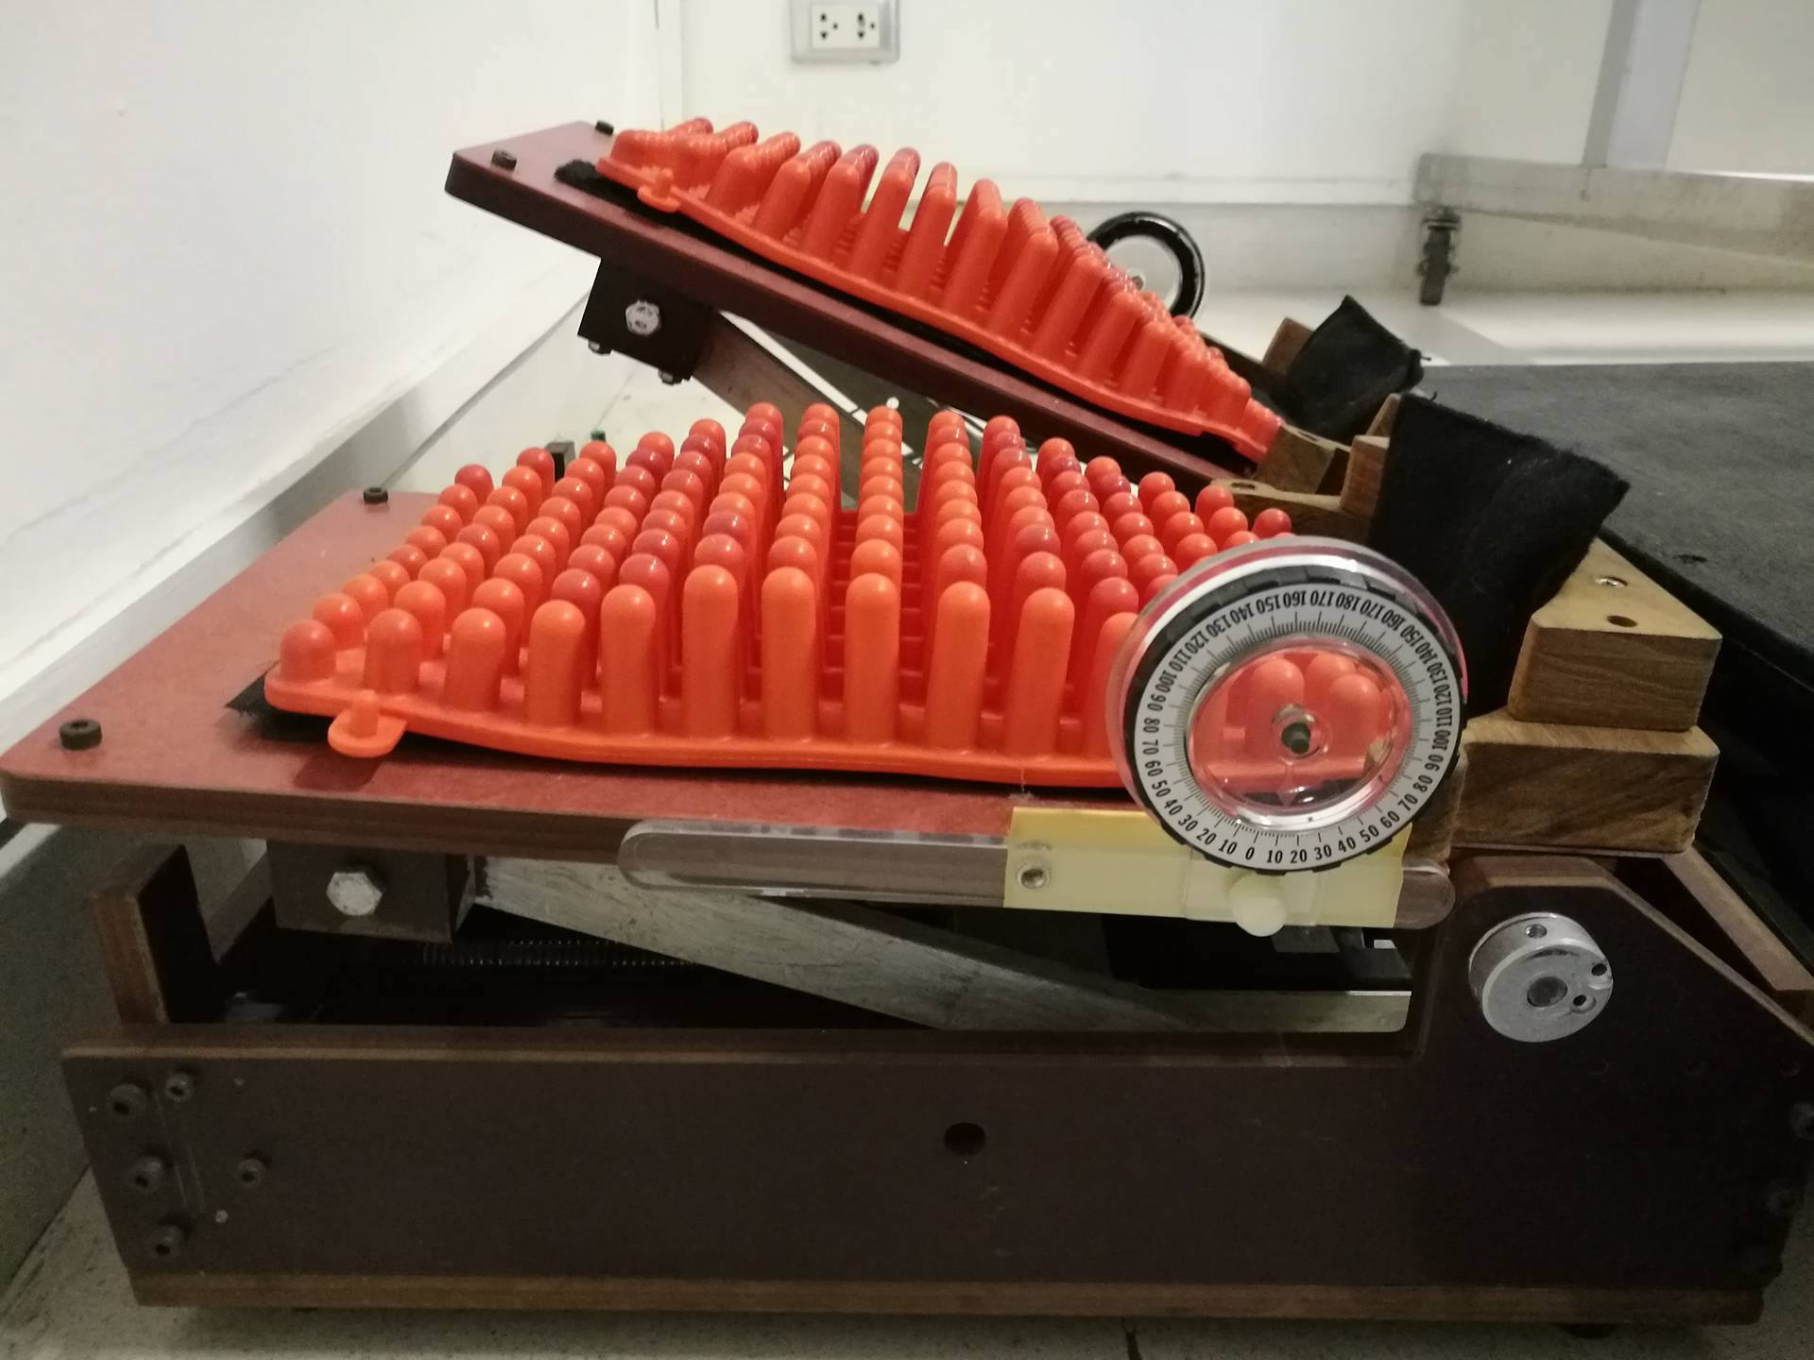
Figure 1 The continuous passive stretching (CPS) instrument.

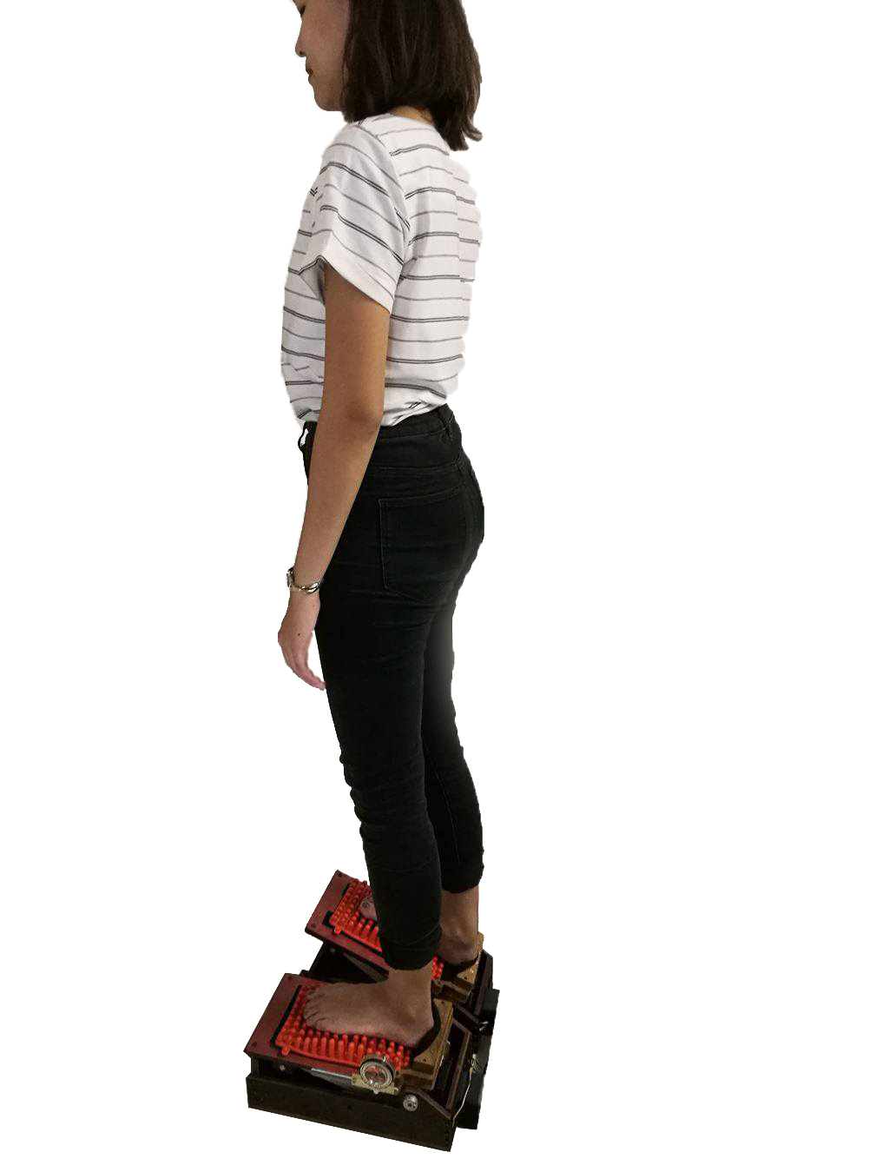 | 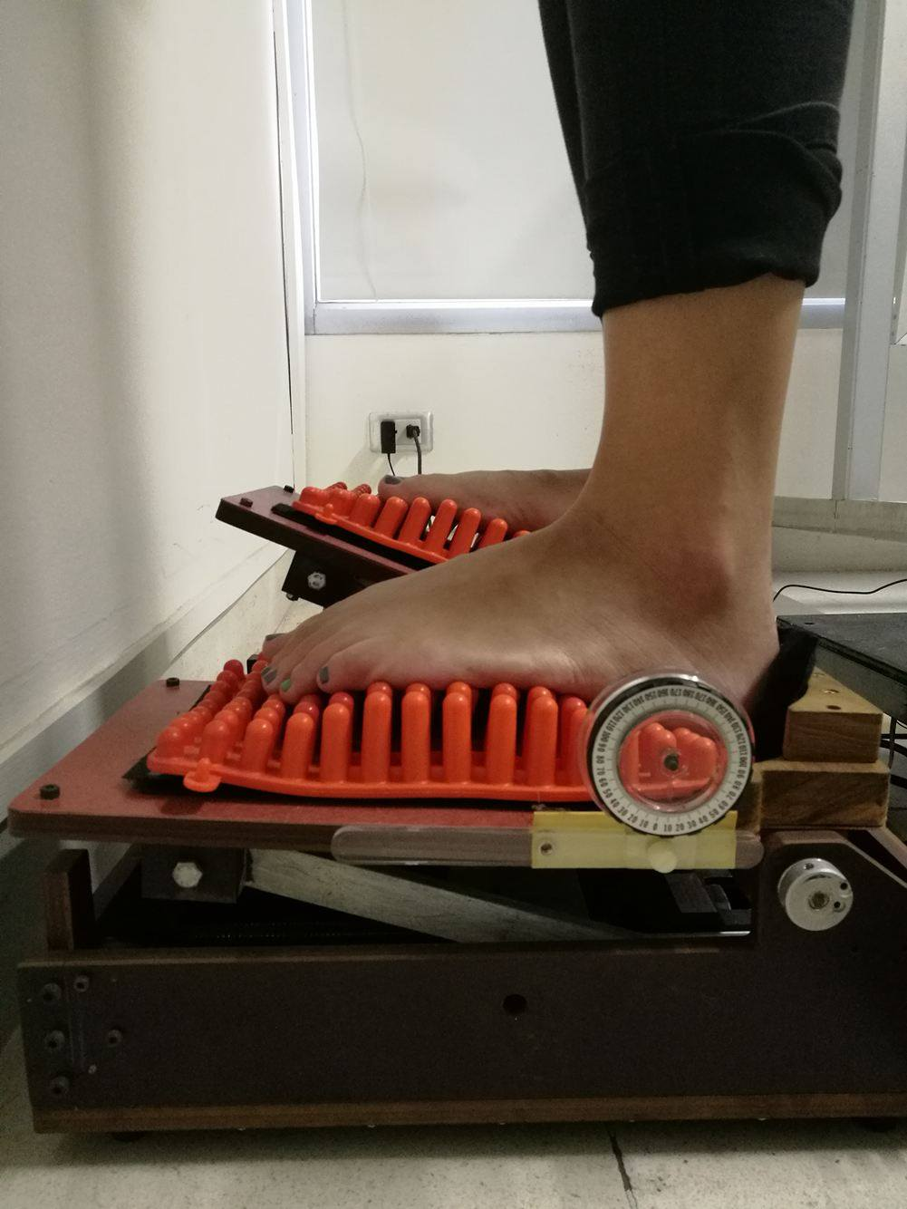
Figure 2 Setting of the participants in the CPS instrument.

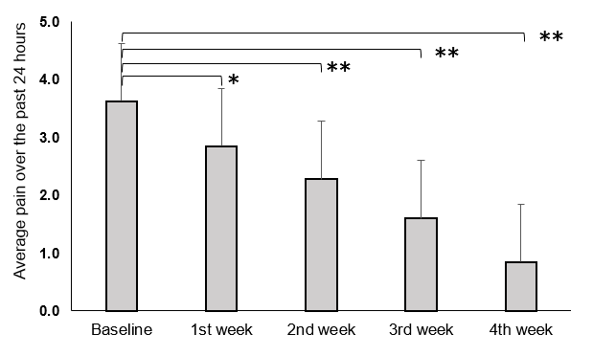
Figure 3 Changes in the average pain intensity over the past 24 hours at the end of each week ( P < 0.05 and P < 0.001).

