**Anti-inflammatory effect of alpha lipoic acid loaded calcium citrate nanoparticle on human keratinocyte HaCaT cells**

Boonyaras Bukkavesa, M.D., Pol.Maj.Gen.1*

*1Police General Hospital, Bangkok, Thailand*

*Tel.: +(66)8-1837-9459 E-mail: boonyaras@hotmail.com*

Siwaporn Nilyai, M.Sc.2

*2Nanomedicine Research Unit, Department of Anatomy, Faculty of Medicine, Chulalongkorn University, Bangkok, Thailand*

*Tel.: +(66)8-9517-2320 E-mail: sariew.nilyai@gmail.com*

Kanidta Sooklert, Ph. D.2

*2Nanomedicine Research Unit, Department of Anatomy, Faculty of Medicine, Chulalongkorn University, Bangkok, Thailand*

*Tel.: +(66)9-1716-5964 E-mail: kanidta.s1986@gmail.com*

Sasin Thamakaison2

*2Nanomedicine Research Unit, Department of Anatomy, Faculty of Medicine, Chulalongkorn University, Bangkok, Thailand*

*Tel.: +(66)6-5378-5692 E-mail: 15749@students.isb.ac.th*

Amornpun Sereemaspun, M.D., Ph.D.2

*2Nanomedicine Research Unit, Department of Anatomy, Faculty of Medicine, Chulalongkorn University, Bangkok, Thailand*

*Tel.: +(66)9-6569-8859 E-mail: amornpun.s@chula.ac.th*

*Correspondence: Boonyaras Bukkavesa

1Police General Hospital, 492/1 Rama 1 Road, Rajprasong Intersection, Pathumwan Bangkok, Thailand.

Tel.: +(66)8-1837-9459

E-mail: boonyaras@hotmail.com

**Running title:** Lipoic nanoparticle anti-inflammation in keratinocytes

**Abstract**

**Background:** Alpha lipoic acid (LA) is potent antioxidant and anti-inflammation natural compound. To enhance the efficacy and stability of LA, LA-loaded calcium citrate nanoparticles were developed.

**Objective:** To investigate the anti-inflammatory effects of LA-loaded calcium citrate nanoparticles (LA-NPs) in HaCaT keratinocytes.

**Methods:** HaCaT cells were exposed under two inflammation stimuli conditions, LPS and Pb(NO3)2, and then were treated with or without LA and LA-NPs for 24 h. Cell viability and pattern of cell death were evaluated. In addition, the expression levels of inflammatory cytokines including IL-1β, IL-6, and TNF-α as well as inflammatory mediator COX-2 were determined by real-time PCR.

**Results:** LA and LA-NPs decreased the percentage of cell death in both LPS and Pb(NO3)2-induced conditions. In LPS-induced cells, LA and LA-NPs attenuated the fold of gene expression levels in IL-1β, IL-6, TNF-α, and COX-2. Decreased expression in proinflammatory cytokines, including IL-1β and IL-6, was also observed in Pb(NO3)2-induced cells.

**Conclusion:** Our study demonstrated the anti-inflammatory effects of LA and LA-NPs on LPS and Pb(NO3)2-induced human keratinocytes.

**Keywords:** Alpha lipoic acid, calcium citrate nanoparticle, anti-inflammation

**Introduction**

Skin, an organ that covers the whole human body, acts as first line of barrier to prevent the entry of harmful substances and environmental stimuli into the body. The skin immune response is an importance mechanism to prevent irritation and injury from toxic or foreign substances such as microorganism infection, UV irradiation, pollutants exposure (1). Owing to the structure of skin, epidermal keratinocytes plays a crucial role in receiving environmental signals and acts as initiator of inflammation through the expression of cytokines and chemokines in activating signaling cascades (2). Although acute inflammation in skin cells is simply a protective reaction towards foreign objects and various stresses, the alteration of skin structure or function from excessive and long-term stress exposure results in chronic inflammation that may lead to development of skin diseases including cancer and premature aging (3, 4).

Protective and therapeutic skin drugs, including cosmeceuticals in topical application, are one of the solutions to treating inflammatory skin diseases. Recently, natural compounds have gained interest over synthetic drugs as alternative therapies because their lack of side effects. One example of a natural compound with potential therapeutic properties is α-Lipoic acid (LA), as it shows potent antioxidant effects (5) and also acts as anti-inflammatory agent under various experimental conditions (6-8). LA plays the essential role as a coenzyme of multiple enzyme complexes and is involved in cellular metabolism (9). LA has also been shown to be involved in the regeneration of other antioxidants such as Vitamin C, Vitamin E (10) as well as glutathione. Furthermore, it has shown properties as a free radical scavenger and has shown antioxidant activity as a metal chelator against some heavy metal ions (11). Furthermore, LA’s anti-inflammation properties were also reported in both *in vitro* and *in vivo* models. In *in vitro* studies, LA has been shown to attenuate the level of inflammatory cytokines, including TNF-α, IL-1β and IL-6 and level of NF-κB, in H2O2-treated fibroblast cells (8) and has also demonstrated the ability to reduce inflammatory cytokine secretion in human keratinocytes (12). In *in vivo* studies, LA has shown an anti-inflammation effect on acute and chronic inflammation in rats because of its strong anti-oxidative potency (13). Moreover, LA showed anti-inflammatory and antiapoptotic effects by reducing TNF-α, iNOS, COX-2 and caspase-3 levels in liver tissue rat hepatic injury (14).

Due to LA’s unique characteristics, it has potential to be therapeutically applied in a wide range of clinical conditions, especially to treat oxidative stress-associated diseases (15). However, LA still possesses various limitations that inhibits its medical applicability: this includes its low stability, low cellular uptake, fast biodegradability, and low penetration capacity in topical administration at the skin (16). This has led several research groups to focus on enhancing LA’s efficacy and stability through combining it with other compounds or through chemical modification. In recent years, nanoparticles-based drug delivery systems have received notable attention because they have the unique capacity in improve the drug stability and increase treatment efficacy (17). The controlled release system of nanoparticles-conjugated compounds allow better penetration and controlled drug release at the target site (17). Among several types of nanoparticles, calcium nanoparticles is one of the most common inorganic compounds that has high availability, low cost, low toxicity, and slow biodegradation. With this, it may be assumed that calcium nanoparticles acts not only to carry drugs in a delivery system but also helps to retain drugs after administration.

Therefore, calcium citrate nanoparticles (CaCitNPs), another type of calcium nanoparticle with beneficial properties, were developed in order to enhance LA’s therapeutic benefits and its control release properties. In this study, LA-loaded calcium citrate nanoparticles (LA-NPs) were synthesized by our novel method outlined in our previous report. Nevertheless, the abilities of LA-NPs still need to be investigated to confirm that they retain the effective activities of the original LA compound. Previously, we have reported that LA-NPs demonstrate the cytoprotective property against H2O2-induced oxidative stress in human keratinocytes (18). However, the anti-inflammatory properties of modified LA-NPs on cells have yet to be investigated. Thus, this study aims to investigate the anti-inflammatory response of human keratinocyte (HaCaT) cells that have been induced by two different types of inflammation trigger agents, lipopolysaccharide (LPS) and lead (II) nitrate (Pb(NO3)2), to synthesized LA-NPs. Viability and cell death pattern of HaCaT cells after treatment with LA and LA-NPs under inflammatory-induced conditions were detected as well as the level of pro-inflammatory cytokines including interleukine-1β (IL-1β), tumor necrosis factor alpha (TNF-α), and interleukine-6 (IL-6). The levels of a mediator of inflammation cyclooxygenase-2 (COX-2) were also determined.

**Materials and Methods**

*LA loaded CaCitNPs (LA-NPs) preparation*

Synthesis of LA loaded CaCitNPs had been clearly explained in our previous study. Briefly, calcium chloride and lipoic acid were mixed together and then trisodium citrate was added and stirred for 10 min. Distilled water was added to discard large particles. The suspension was centrifuged in order to collect the precipitate and store it as stock in powder form. Before usage in the experiment, fresh LA-loaded CaCitNPs were dissolved in distilled water and sonicated.

*Cell cultures*

Human keratinocyte cell line, HaCaT, was purchased from American Type Culture Collection (ATCC, USA). The cells were cultured in Dulbecco’s modified Eagle’s medium (DMEM) supplemented with 10% fetal bovine serum (FBS) and 1% antibiotics at 37 °C in 5% CO2 humidified atmosphere.

*Viability measurement*

HaCaT cells were seeded at density 1x104 cells in 96-well plate and incubated overnight. The cells were pre-incubated with LPS or Pb(NO3)2 and were then treated with or without LA and LA-NPs for 24 h. Viability of cells were determined by PrestoBlue™ cell viability reagent (Invitrogen, USA), and cell permeable reasazurin-based solution. After incubation, 10 µl of PrestoBlue® were added to each well and then the samples were incubated at 37 °C for 30 min. Fluorescence intensity of viable cells were detected by Varioskan Flash microplate reader (Thermo Scientific, USA) at 560 nm emission and 590 nm excitation.

*Cell death pattern*

To determine pattern of cell death after exposure to inflammatory conditions and treatment with LA and LA-NPs, Annexin V and propidium iodide (PI) staining were used. HaCaT cells were seeded into 12-well plate at 5x105 cell each well and incubated overnight. After 24 h of treatment, the cells were collected and resuspended in 1x phosphate buffer saline (PBS). The pellet of cells after centrifugation were stained with fluorescein isothiocyanate (FITC)-conjugated Annexin V and PI (BD Biosiciences, USA) for 15 min at room temperature in dark place. The cells were analyzed by flow cytometry instrument (Backman Coulter CytoFlex, USA).

*Inflammatory gene expression*

After 24 h incubation, the treated cells were harvested for gene expression analysis. Total RNA was extracted using TRIzol reagents (Invitrogen, USA). Concentration of isolated RNA of each sample was measured using NanoDrop™ spectrophotometers (Thermo Scientific), and 500 ng/µl of total RNA was employed in the next step. Quantitative real-time PCR was performed on ABI step-one plus using SensiFAST™ SYBR® One-Step Kit (Bioline, UK). Total RNA was converted into cDNA and target gene expression was amplified in one-step Real-Time PCR using the following conditions: reverse transcription at 45 °C for 10 min, polymerase activation at 95 °C for 2 min and 40 cycles of denaturation and annealing were performed at 95 °C for 5 s and 60 °C for 30 s, respectively. Sequence of gene-specific primers were as follows: IL-1β forward, 5’-AGA-TGA-TAA-GCC-CAC-TCT-ACA-G-3’ and reverse, 5’ACA-TTC-AGC-ACA-GGA-CTC-TC-3’; IL-6 forward, 5’-GTGTGAAAGCAGCAAAGAG-3’ and reverse, 5’-CTCCAAAAGACCAGTGATG-3’; TNF-α forward, 5’ -TCCTTCAGACACCCTCAACC-3’ and reverse, 5’-AGGCCCCAGTTTGAATTCTT-3’; COX-2 forward, 5’-TTCTCCTTGAAAGGACTTATGGGTAA-3’ and reverse, 5’-AGAACTTGCATTGATGGTGACTGTTT-3’; GAPDH forward, CAT-CAC-CAT-CTT-CCA-GGA-GCG and reverse, GAG-GGG-CCA-TCC-ACA-GTC-TTC. Melt curve analysis was performed to confirm the specificity of the amplified product. Fold changes of gene expression were calculated using comparative Ct method (2-∆∆Ct) and relative expression of inflammatory genes were calculated using GAPDH as a housekeeping control.

*Statistical analysis*

All data were analyzed using GraphPad Prism and results were expressed as mean±SD. One-way analysis of variance (ANOVA) was used to detect significant differences between treatment groups followed by Tukey’s post hoc multiple comparison test. Results were considered to be significantly different when *p* values were < 0.05.

**Results**

*Cell viability*

To determine the cytotoxicity of the inflammation-inducing agents and the effects of LA and LA-NPs on keratinocytes under inflammation-triggered condition, cells were exposed with 10 µg/ml LPS and 100 µg/ml Pb(NO3)2 and were treated with or without LA and LA-NPs at concentration 5 and 10 µg/ml for 24 h (Fig 1). LPS and Pb(NO3)2 slightly decreased the percentage of cell viability. However, the cells exposed with LPS and LA at 10 µg/ml showed a significant increase in percentage of viability than LPS treatment alone. Also, the cells exposed to Pb(NO3)2 with LA at 10 µg/ml and LA-NPs at 5 and 10 µg/ml showed significantly increased percentage of viability compared to Pb(NO3)2 alone.

*Cell death pattern*

To evaluate the effect of LA and LA-NPs on the cell death pattern of cells treated with LPS or Pb(NO3)2 , annexin V-FITC/PI staining was performed using flow cytometry analysis. Cells were induced with 10 µg/ml of LPS (Fig. 2A-B) or 100 µg/ml of Pb(NO3)2 (Fig. 2C-D) and were treated with LA or LA-NPs 10 µg/ml for 24 h. The results showed both inflammatory-induced agents can induce necrosis in HaCaT cells as 25.23% and 29.3% of total cells in LPS and Pb treatment, respectively. On the other hands, in treatment with LA and LA-NPs 10 µg/ml with LPS can decrease percentage of necrotic cells into 11.23 and 12.24, respectively. The same results were found in Pb(NO3)2–induced group as 10.29% and 8.37% of necrotic cells in LA and LA-NPs treatment, respectively.

*Gene expression level of inflammatory cytokines*

Real-time PCR was performed to detect the mRNA expression level of inflammatory cytokines, including IL-1β, IL-6, TNF-α, and COX-2, in cells exposed to LPS or Pb(NO3)2 alone compared to the groups that combined treatment with LA or LA-NPs. As shown in Fig 3., LPS-induced cells demonstrated significantly increased genes fold changes of IL-6, TNF-α and COX-2 from the control. IL-1β in LPS-induced cells also demonstrated a slight increase in expression level. Combined treatment of LPS and LA attenuated the levels of IL-6, TNF-α and COX-2. LA-NPs with LPS-treated cells showed suppression of IL-1β, IL-6 and TNF-α levels. However, the expression of all inflammatory cytokines showed no statistically significant difference between LA and LA-NPs treatment groups. The same results showed in Pb(NO3)2-treated groups for expression of IL-1β and IL-6 (Fig. 4 A and B).

**Discussion**

LA is a natural compound that exhibits various potent antioxidant and anti-inflammation properties that candidates it to be used as therapeutic drug for several diseases (19). For skin, drugs in topical application form is effective because it can reach the target site directly. LA might be developed to potentially be used as anti-inflammatory drug for skin diseases but its properties of low skin penetration and low bioavailability are still critical limitations. Our research group has modified the LA drug delivery system through calcium citrate nanoparticles and have demonstrated in the previous report that LA-conjugated calcium citrate nanoparticles can better protect the keratinocyte cells from oxidative stress induced agents than LA alone (18). In this study, we showed the anti-inflammatory effect of LA-NPs under LPS- and Pb(NO3)2 induced conditions.

Lipopolysaccharide (LPS), a major component of the outer membrane of Gram-negative bacteria, has been demonstrated to be a key molecule in triggering an immune response through the activation proinflammatory cytokines and chemokines (20). Prolonged exposure to LPS can lead to cell injury and necrosis (21). Previous study has revealed that LPS can activate proinflammatory cytokines, including IL-1β, IL-6, and TNF-α, in keratinocyte cells (22). COX-2, a prostaglandin-endoperoxide synthase (PTGS), is readily induced in response to inflammatory stimuli, including LPS. Since the critical role of COX-2 in mediating inflammatory processes and involvement in pathogenesis has been verified in skin model, it is determined as anti-inflammatory-targeted molecule. (23). Therefore, LPS were used in this study as the stimuli to construct *in vitro* cell skin inflammation model. In this study, we found that LA-NPs and LA can inhibit expression of IL-1β, IL-6, TNF-α, and COX-2 in LPS-induced HaCaT cells along with improve percentage of cell death. Protective effects of LA in LPS-induced models have been reported (20, 24, 25). In addition, LA has been shown ability in decrease IL-1β, IL-6, TNF-α level in H2O2-induced in rat embryonic fibroblast cells (8) and suppress expression of IL-1β, IL-6, TNF-α, and COX-2 in LPS-induced kidney cells (26). A previous study of LPS-induced monocytes demonstrated that LA inhibit the effect of LPS by activating the PI3K/Akt pathway (27). To investigate effect of LA-NPs on other toxic substances, lead (II) nitrate (Pb(NO3)2) was selected to stimulate an inflammatory response of an environment pollutant, as the toxic effects of Pb2+ are associated with inflammatory diseases (28). The results of several studies have clearly confirmed that Pb plays a crucial role in development of inflammation by acting on the level of gene expression and the production of proinflammatory proteins (29). In our study, 100 µg/ml of Pb(NO3)2 showed an increased percentage of cell death and increased expression levels of IL-1β and IL-6 proinflammatory genes. As expected, LA-NPs and LA can suppress both IL-1β and IL-6 expression and improve the level of viability cells. As a result of this study, LA-NPs have showed potential in attenuating the expression of proinflammatory cytokines in both LPS and Pb(NO3)2-induced keratinocyte cells.

LA-NPs and LA demonstrated the same strength of anti-inflammatory effect in LPS and Pb(NO3)2-induced HaCaT cells. However, because of the drug-delivery nanoparticle-assembling process, the concentration of LA in LA-NPs was not comparable with that of LA alone. As the drug loading capacity of LA-NPs limits the amount of LA encapsulated into calcium citrate, the exact amount of LA in LA-NPs must be less than weighted. The previous study has been revealed that calcium nanoparticles can improve the efficiency of drug delivery by enhancing cellular uptake (30). Moreover, drugs or bioactive proteins in calcium nanoparticles system have reported good sustained-release performance and high stability (17). Therefore, the equal anti-inflammatory effect of LA and LA-NPs, which is composed of a smaller amount of LA, may be due to calcium nanoparticles’ beneficial properties.

In the present study, we demonstrated the anti-inflammatory effect of LA-NPs on keratinocyte cells via attenuated expression of associated inflammatory cytokines in both LPS and Pb(NO3)2-induced models. These findings provide support for the effect of modified LA on inflammatory responses of skin cells. However, the mechanisms of LA in nanoparticles-based delivery form and the specific properties of calcium nanoparticles that encourage LA-NP’s effect on keratinocyte cells are still unknown and needs to be clarified in further research.

**Conclusion**

In this study, modified LA-loaded calcium citrate nanoparticles demonstrated an anti-inflammatory effect that was same as LA in different toxic substance-induced inflammation conditions in skin cells models. However, the efficacy of controlled release system of nanoparticles-based should be investigated and stability of LA with carrier must be verified in future studies.

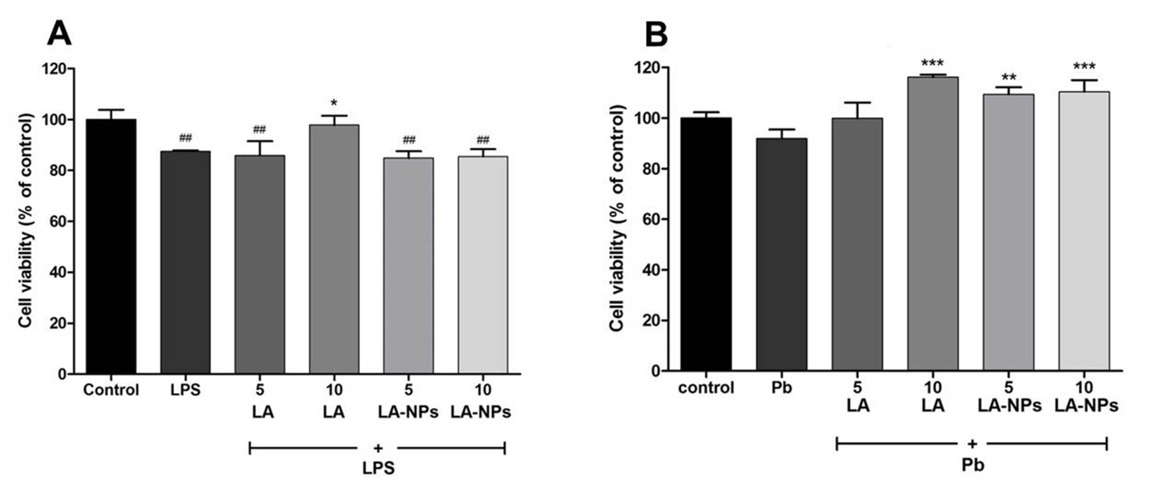

Fig 1. Effects of LA and LA-NPs on viability in HaCaT cells treated with LPS (A) and Pb(NO3)2 (B). Cells were treated with 10 and 100 µg/ml LPS and Pb(NO3)2, respectively and then treated with 5 and 10 µg/ml LA or LA-NPs for 24 h. Fluorescence of viable cells were detected. Data represent the mean value of triplicate ± SD. ##*p* < 0.01 versus control and \**p* < 0.05 \*\**p* < 0.01 \*\*\**p* < 0.001 versus LPS or Pb.

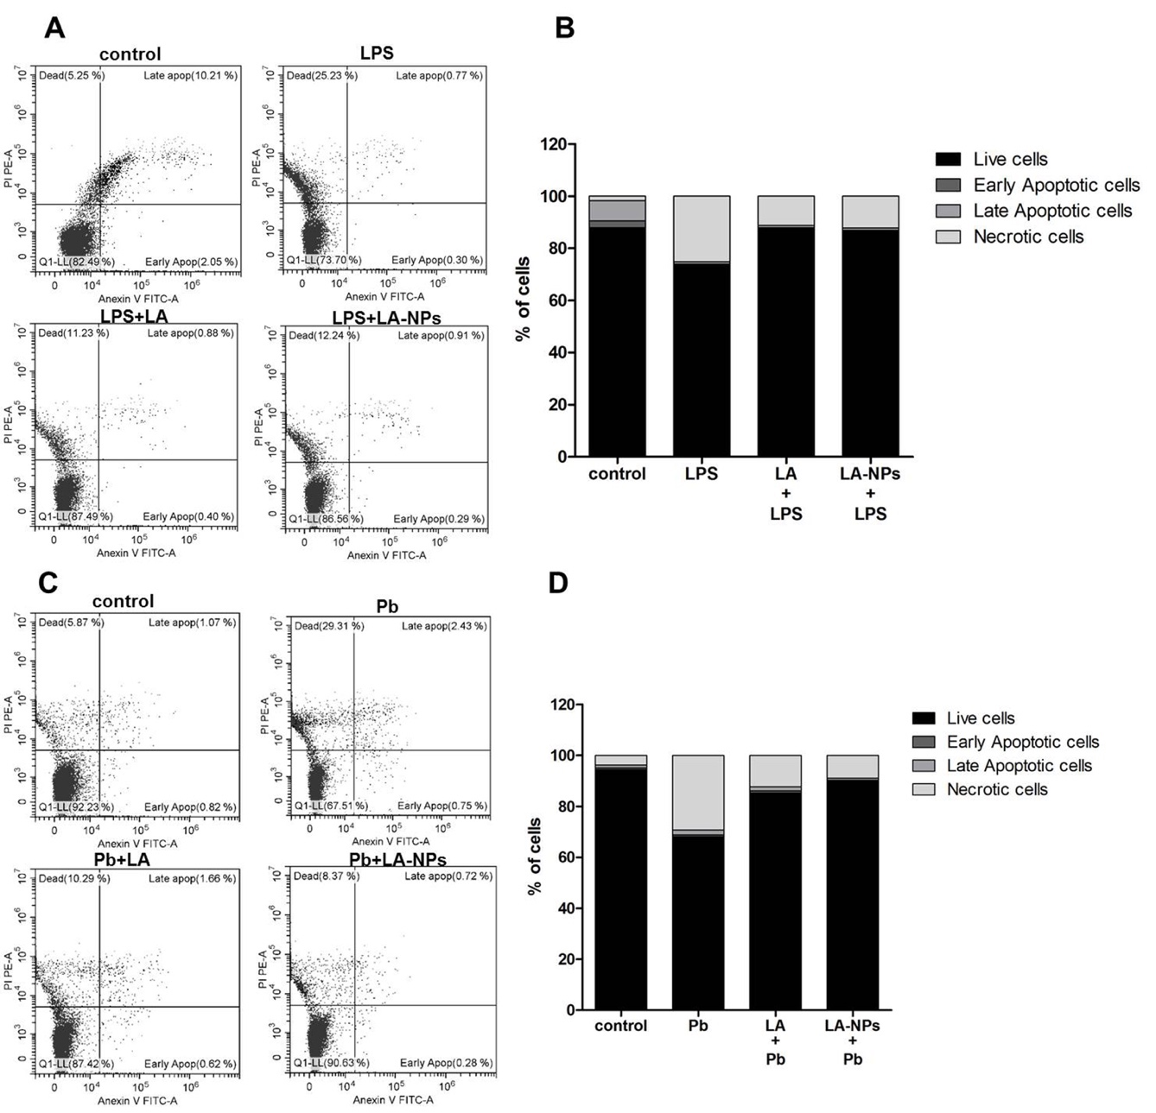

Fig 2. Effects of LA and LA-NPs on death pattern of HaCaT cells treated with LPS (A and B) and Pb(NO3)2 (C and D). Cells were treated with 10 and 100 µg/ml LPS or Pb(NO3)2, respectively and then treated with 10 µg/ml LA or LA-NPs for 24 h. Cell dead pattern were detected by annexin V-FITC/PI staining. A) and C) showed scatter plots of annexin V-FITC/PI staining. B) and D) represented quantitative analysis.

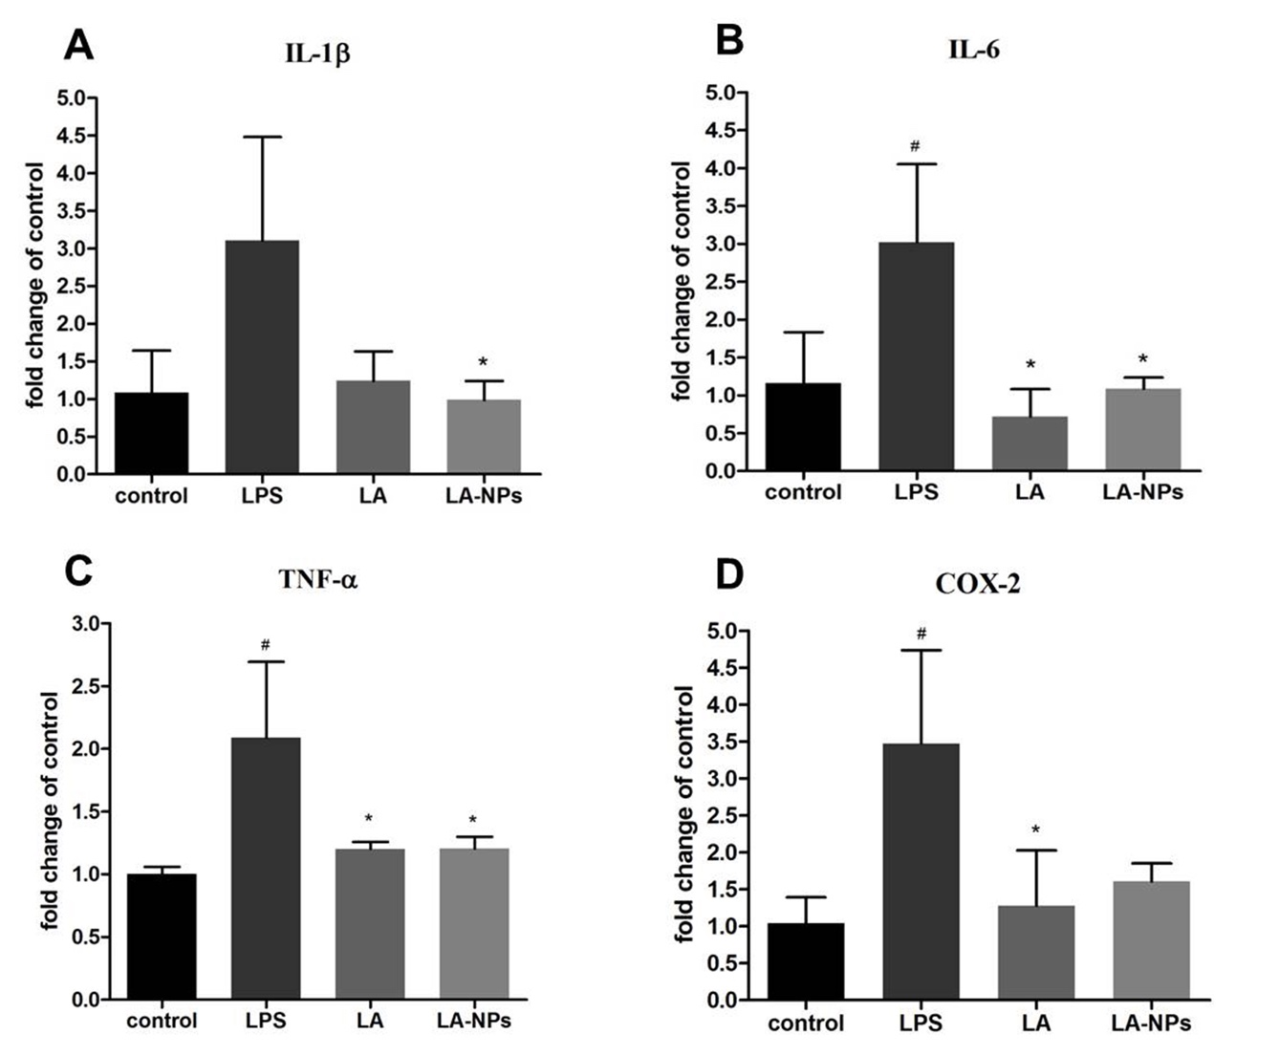

Fig 3. Effects of LA and LA-NPs on mRNA expression level of pro-inflammatory cytokine in LPS-induced HaCaT cells. Cells were treated with 10 µg/ml LPS and then treated with 10 µg/ml LA or LA-NPs for 24 h. The mRNA levels of IL-1β (A), IL-6 (B), TNF-α (C), and COX-2 (D) were detected by Real-time PCR. Data represent the mean value of triplicate ± SD. *#p* < 0.05 versus control and *\*p* < 0.05 versus LPS.

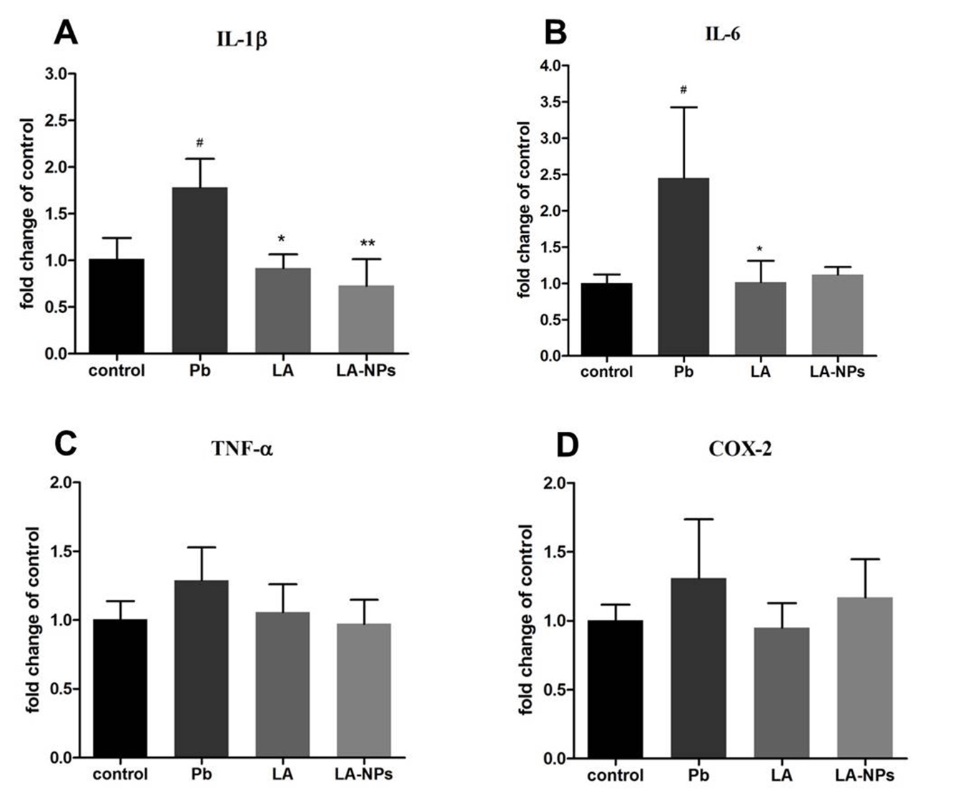

Fig 4. Effect of LA and LA-NPs on the mRNA level of pro-inflammatory cytokine in Pb(NO3)2-induced HaCaT cells. Cells were treated with 100 µg/ml Pb(NO3)2 and then treated with 10 µg/ml LA or LA-NPs for 24 h. The mRNA levels of IL-1β (A), IL-6 (B), TNF-α (C), and COX-2 (D) were detected by Real-time PCR. Data represent the mean value of triplicate ± SD. *#p* < 0.05 versus control. *\*p* < 0.05 and \*\**p* < 0.01versus Pb.

**Acknowledgments**

The authors gratefully acknowledge the Grant to support a research group in the Research Unit Endowment Fund, Chulalongkorn University.

**Conflict of Interest**

The authors report no conflicts of interest.

**References**

1. Suter MM, Schulze K, Bergman W, Welle M, Roosje P, Muller EJ. The keratinocyte in epidermal renewal and defence. Veterinary dermatology. 2009;20(5-6):515-32.

2. Pasparakis M, Haase I, Nestle FO. Mechanisms regulating skin immunity and inflammation. Nature reviews Immunology. 2014;14(5):289-301.

3. Aggarwal BB, Shishodia S. Molecular targets of dietary agents for prevention and therapy of cancer. Biochemical pharmacology. 2006;71(10):1397-421.

4. Mueller MM. Inflammation in epithelial skin tumours: old stories and new ideas. Eur J Cancer. 2006;42(6):735-44.

5. Aziza S. The Potent Antioxidant Alpha Lipoic Acid. J Plant Chem and Ecophysiol 2017; 2(1): 1016. 2017;2:1016.

6. Jameel NM, Shekhar MA, Vishwanath BS. Alpha-lipoic acid: an inhibitor of secretory phospholipase A2 with anti-inflammatory activity. Life sciences. 2006;80(2):146-53.

7. Yildirim Bas F, Bayram D, Arslan B, Armagan I, Yesilot S, Cicek E, et al. Effect of alpha lipoic acid on smoking-induced skin damage. Cutaneous and ocular toxicology. 2017;36(1):67-73.

8. Baeeri M, Bahadar H, Rahimifard M, Navaei-Nigjeh M, Khorasani R, Rezvanfar MA, et al. alpha-Lipoic acid prevents senescence, cell cycle arrest, and inflammatory cues in fibroblasts by inhibiting oxidative stress. Pharmacological research. 2019;141:214-23.

9. Packer L, Witt EH, Tritschler HJ. Alpha-lipoic acid as a biological antioxidant. Free Radical Biology and Medicine. 1995;19(2):227-50.

10. Lu C, Liu Y. Interactions of lipoic acid radical cations with vitamins C and E analogue and hydroxycinnamic acid derivatives. Archives of biochemistry and biophysics. 2002;406(1):78-84.

11. Biewenga GP, Haenen GRMM, Bast A. The pharmacology of the antioxidant lipoic acid. General Pharmacology: The Vascular System. 1997;29(3):315-31.

12. Pastore S, Lulli D, Potapovich AI, Fidanza P, Kostyuk VA, Dellambra E, et al. Differential modulation of stress-inflammation responses by plant polyphenols in cultured normal human keratinocytes and immortalized HaCaT cells. Journal of dermatological science. 2011;63(2):104-14.

13. Odabasoglu F, Halici Z, Aygun H, Halici M, Atalay F, Cakir A, et al. α-Lipoic acid has anti-inflammatory and anti-oxidative properties: an experimental study in rats with carrageenan-induced acute and cotton pellet-induced chronic inflammations. British Journal of Nutrition. 2011;105(1):31-43.

14. Fayez AM, Zakaria S, Moustafa D. Alpha lipoic acid exerts antioxidant effect via Nrf2/HO-1 pathway activation and suppresses hepatic stellate cells activation induced by methotrexate in rats. Biomedicine & pharmacotherapy = Biomedecine & pharmacotherapie. 2018;105:428-33.

15. Smith AR, Shenvi SV, Widlansky M, Suh JH, Hagen TM. Lipoic Acid as a Potential Therapy for Chronic Diseases Associated with Oxidative Stress. Current Medicinal Chemistry. 2004;11(9):1135-46.

16. Koufaki M. Therapeutic applications of lipoic acid: a patent review (2011 - 2014). Expert opinion on therapeutic patents. 2014;24(9):993-1005.

17. Maleki Dizaj S, Barzegar-Jalali M, Zarrintan MH, Adibkia K, Lotfipour F. Calcium carbonate nanoparticles as cancer drug delivery system. Expert Opinion on Drug Delivery. 2015;12(10):1649-60.

18. Bukkavesaa B, Sooklert K, Sereemaspun A. Protective effect of alpha lipoic acid loaded calcium citrate nanoparticle on oxidative stress-induced cellular damage in human epidermal keratinocyte. Chula Med J 2019;63:261-9.

19. Moura FA, de Andrade KQ, dos Santos JC, Goulart MO. Lipoic Acid: its antioxidant and anti-inflammatory role and clinical applications. Current topics in medicinal chemistry. 2015;15(5):458-83.

20. Lin YC, Lai YS, Chou TC. The protective effect of alpha-lipoic Acid in lipopolysaccharide-induced acute lung injury is mediated by heme oxygenase-1. Evidence-based complementary and alternative medicine : eCAM. 2013;2013:590363.

21. Yucel G, Zhao Z, El-Battrawy I, Lan H, Lang S, Li X, et al. Lipopolysaccharides induced inflammatory responses and electrophysiological dysfunctions in human-induced pluripotent stem cell derived cardiomyocytes. Scientific reports. 2017;7(1):2935.

22. Li S, Xie R, Jiang C, Liu M. Schizandrin A Alleviates LPS-Induced Injury in Human Keratinocyte Cell Hacat Through a MicroRNA-127-Dependent Regulation. Cellular physiology and biochemistry : international journal of experimental cellular physiology, biochemistry, and pharmacology. 2018;49(6):2229-39.

23. Lee JL, Mukhtar H, Bickers DR, Kopelovich L, Athar M. Cyclooxygenases in the skin: pharmacological and toxicological implications. Toxicology and applied pharmacology. 2003;192(3):294-306.

24. Goraca A, Jozefowicz-Okonkwo G. Protective effects of early treatment with lipoic acid in LPS-induced lung injury in rats. Journal of physiology and pharmacology : an official journal of the Polish Physiological Society. 2007;58(3):541-9.

25. Goraca A, Piechota A, Huk-Kolega H. Effect of alpha-lipoic acid on LPS-induced oxidative stress in the heart. Journal of physiology and pharmacology : an official journal of the Polish Physiological Society. 2009;60(1):61-8.

26. Suh SH, Lee KE, Kim IJ, Kim O, Kim CS, Choi JS, et al. Alpha-lipoic acid attenuates lipopolysaccharide-induced kidney injury. Clinical and experimental nephrology. 2015;19(1):82-91.

27. Zhang WJ, Wei H, Hagen T, Frei B. Alpha-lipoic acid attenuates LPS-induced inflammatory responses by activating the phosphoinositide 3-kinase/Akt signaling pathway. Proceedings of the National Academy of Sciences of the United States of America. 2007;104(10):4077-82.

28. Tsai YT, Chang CM, Wang JY, Hou MF, Wang JM, Shiurba R, et al. Function of DNA methyltransferase 3a in lead (Pb(2+) )-Induced Cyclooxygenase-2 gene. Environmental toxicology. 2015;30(9):1024-32.

29. Metryka E, Chibowska K, Gutowska I, Falkowska A, Kupnicka P, Barczak K, et al. Lead (Pb) Exposure Enhances Expression of Factors Associated with Inflammation. International journal of molecular sciences. 2018;19(6). Epub 2018/06/22.

30. Wang C-Q, Gong M-Q, Wu J-L, Zhuo R-X, Cheng S-X. Dual-functionalized calcium carbonate based gene delivery system for efficient gene delivery. RSC Advances. 2014;4(73):38623-9.