**CT histogram analysis of primary renal cell carcinoma in different subtypes**

Sirikarn Praserttrakul, Kewalee Sasiwimonphan*

*Division of Diagnostic Radiology, Department of Radiology, Faculty of Medicine, Chulalongkorn University, Bangkok, Thailand*

**ABSTRACT**

**Background and objectives**: Each type of renal cell carcinoma (RCC) has variable natural history, growth rates, histopathologic features, clinical behaviors and image features which possible changes in management. The purpose of this study is to evaluate the use of ROI-based CT histogram distribution analysis for differentiate subtypes of RCC and to determine correlation between histogram distribution parameters and nuclear grade of RCC.

**Materials and Methods**: ROI-based method to measured mean and median pixel attenuation and histogram distribution analysis was performed on pre-operative CT images of pathologically proven RCCs in 77 patients. Statistical analysis for comparison of histogram parameters in each phase of CT examination, as well as, assessment of observer concordance and assessment of correlation between a nuclear grade and pixel attenuation as well as histogram parameters were also performed.

**Results**: There are statistically significant higher in mean and median pixel attenuation of clear cell RCC than that of papillary RCCs in arterial phase and statistically significant higher in mean and median pixel attenuation of clear cell RCCs than that of non-clear cell RCCs in portovenous/nephrographic phase. Skewness of clear cell RCCs in portovenous/nephrographic phase shown statistically significantly lower than that of papillary RCCs.

**Conclusions:** ROI-based CT evaluation might be a promising way to differentiated subtypes of RCCs but should be interpreted with caution and further investigation in larger number of non-clear cell RCC and other histogram analysis on two-dimensional image software might be useful to confirm the results.

**Keywords**: CT histogram analysis, renal cell carcinoma, ROI-based

**\*Correspondence to:** Kewalee Sasiwimonphan, Division of Diagnostic Radiology, Department of Radiology, Faculty of Medicine, Chulalongkorn University, Bangkok 10330, Thailand.

E-mail: kewalees@gmail.com Phone: +66-2-256-4417-8

**INTRODUCTION**

**Background**

Renal masses have increasingly been discovered unintentionally as the use of diagnostic imaging modalities such as CT scan for other purpose rises. These incidental findings of renal cell carcinomas (RCCs) can lead to a management dilemma because these malignant tumors have variable natural history, growth rates, histopathologic features, and clinical behaviors.

According to the updated 2016 WHO classification which is more detailed, but the main types remain quite the same, the main types of RCC including clear cell RCCs, papillary RCCs, chromophobe RCCs, collecting duct carcinoma, renal oncocytoma and unclassified tumor (1). Incidences of RCC subtypes have been reported as followings; clear cell RCCs (65%), papillary RCCs (15%), chromophobe RCCs (5%), collecting duct carcinoma (1%), renal oncocytoma (5%) and unclassified tumor (5%).

There is also histopathologic grading of the nuclei of the tumor according to the International Society of Urological Pathology (ISUP) 2013 which have four grades which grade 1 is the best-differentiated and grade 4 is the most anaplastic or having tumor giant cell and/or rhabdoid/sarcomatoid differentiation (1). This classification includes multiple different malignancies profoundly diverse in terms of morphological and immunohistochemical features, molecular genetic profile, clinical behavior, and prognosis (2).

In general, a common management of RCC is through nephrectomy for both treatment and definite diagnosis. The group of large primary tumors which are more likely to have a metastatic disease at initial presentation, the treatment does not include nephrectomy (3) and the choices of systemic therapy may significantly vary, depending on whether a clear cell or non–clear cell RCC is diagnosed (4). The other group of the small renal masses (<4 cm), in which, nephron sparing strategies (partial nephrectomy, ablative therapies) are the more preferred treatment methods. The non-invasive strategy for this group is through an active surveillance by following up radiographic imaging. This option of care is particularly suitable for elderly, patients with significant comorbidities (5), or the lesion measured less than 2 cm in size. If the more confident prospective characterization of common histologic subtypes of RCC were possible, it would infer that lesions which were strongly believed to represent the more indolent variants of RCC (i.e., papillary RCC, chromophobe RCC or benign oncocytoma) could be monitored and followed through rather than resected.

Although percutaneous biopsy of the renal tumor can enable an accurate histologic diagnosis among many patients, in large RCC, in which, an advanced stage RCC is suspected, the potentials for sampling error and associated procedural complications have hindered wide scale clinical acceptance (6). Furthermore, in patients whom active surveillance is being considered as a management option, biopsy remains an invasive method for attaining a definite diagnosis, thus, radiographic imaging has become a promising choice of diagnosis. Since different histopathologic subtypes of RCC produce different features on diagnostic imaging, the radiographic modalities such as CT scan or MRI may become a more useful method of classifying RCC subtypes.

This paper will be focus on CT imaging which is more available than MRI and generally provide a useful method of differentiating subtypes of RCC based on visual or qualitative inspection of contrast enhancement (7). However, quantitative methods such as measuring enhancement or CT textural analysis may provide a higher degree of accuracy with less subjective variability.

Histogram analysis is the method based on the distribution of tissue attenuation in the mass. This method enables diagnosis of many adrenal adenoma with contrast-enhanced CT as compared to the conventional 10-HU threshold-based method based on heterogeneous tissue composition in adrenal adenomas (8). CT histogram analysis may also be useful for differentiating angiomyolipoma without visible fat from RCC at CT (9).

The recent studies show that CT texture features: particularly the entropy, the standard deviation (SD) of the pixel distribution histogram and the mean of positive pixels, are associated with histologic type, nuclear grade, and clinical outcomes in large RCC (10). The voxel-based whole lesion enhancement parameters can be used as a quantitative tool to differentiate a clear cell RCC from papillary RCC; however, it remains unclear whether a whole lesion evaluation is more accurate than the ROI-based assessment (11). In these days, not every workstation has an ability to predict CT texture feature or three-dimensional image analysis, thus, histogram analysis on two-dimensional image with program that available for free such as “Image J” which make it more feasible and more available on a standard CT workstation, might be a practical way to differentiate subtypes of RCC in quantitative method.

**Objective**

This study objective is to determine whether CT histogram distribution analysis can differentiate subtypes of RCC or not and to determine correlation between histogram distribution parameters and nuclear grade of RCC.

**MATERIALS & METHODS**

**Patient selection**

At first, data from multiple RCCs from the same patient were collect separately obtaining from KCMH’s (King Chulalongkorn Memorial hospital) pathological database merging with radical nephrectomy database form urology department between January 2011 and December 2017 generated a list of 145 RCCs. Then the pathological reports were retrospectively reviewed including histologic subtypes, nuclear grades, date of surgery, methods of surgery and site of the affected kidney.

Since 38 pathological reports that launched in 2011-2014 reported nuclear grading according to Fuhrman grading system, pathological review for nuclear grading system into WHO/ISUP 2016 system by 2 years experiences pathologist staff from KCMH’s pathology department was done in 35 lesions which had available pathological slides.

Of these 145 RCCs, 57 RCCs were excluded because they did not have pre-operative CT images yielding total 88 RCCs in this study. Due to awareness of intrapersonal effect in the same patients with more than one RCCs, selection the largest one to analyze was done. 2 patients with clear cell and papillary RCC and 1 patient with clear cell and papillary versus acquired cystic diseased-associated RCC were excluded due to inability to classified in to clear cell or papillary category. Yielding total of 77 patients in this study.

The approval of Institutional Review Board (IRB) at KCMH was obtained with waiver of informed consent due to retrospective nature of the study.

**Image acquisition**

All CT examinations were performed by a MDCT scanner before the patient underwent a surgery. Examinations were classified into series on the basis of the contrast phase (unenhanced, arterial phase (40 seconds after IV administration of contrast medium, venous/nephrogenic phase (about 70-90 seconds), and delayed phase (ranging from 1-16 minutes). 62 patients had all phases, 7 patients had no delayed phase, 5 patients had no arterial phase, 2 patients had no arterial and delayed phases while 2 patients had no portovenous/nephrographic and delayed phases. Imaging parameters were as follows: a tube potential of about 120 kVp, 200-250 mAs. Slice thickness is ranging from 1-5 mm.

CT examinations which performed on the date closest to the date of surgery were selected for further analysis. Only 62 CT examinations had all phases (including non-contrast, arterial, portovenous/nephographic, and delayed phases). All of the CT examinations included non-contrast phase, but not all of the CT examinations have all contrast phases (non-contrast phase (n = 77), arterial phase (n = 70), portovenous/nephographic phase (n = 76) and delayed phase (n = 66). Delayed time in the CT examinations was varies, ranging from 1 – 16 minutes (median = 9 minutes).

**Image analysis**

Measurements were performed separately for each examination. A single slice at the level of the overall maximal cross-sectional diameter of the tumor was selected. If a patient had images obtained in more than one contrast enhancement phases, the same slice level would be manually selected for all phases. Maximal diameter was measured. The selected single-slice images were sent to a software program called “ImageJ”. With the use of the software, an elliptical ROI (region of interest) was placed on the tumor in conjunction by two observers. First observer is a resident of radiology department and second observer is an experienced attending abdominal imaging radiologist. If possible, approximately all of the mass was measured, but avoid the area of necrosis as defined as a focal area of hypoattenuation as compared with the remainder of the mass. The ROIs were drawn around the lesions in each of the phases using roughly equal boundaries and matched slices. The software program measured and plotted the pixel attenuation versus pixel frequency of the area in ROI and were displayed to histogram parameters including mean/median pixel attenuation, the SD of the pixel distribution histogram, the mean of positive pixel, kurtosis and skewness then subsequently analyzed (Figure 1).

**Statistical analysis**

Firstly, we testeddata distribution of pixel attenuation and histogram parameters in each phase based on box plot. Then performed statistical analysis for comparison of histogram parameters in each phase of CT examination of clear cell RCCs, papillary RCC, chromophobe RCC and unclassified, including other types of RCC by Kruskal Wallis H test and compared between two groups of RCCs using Wilcoxon rank-sum test. Then, select imaging parameters and phases (with high significant level) to plot receiver operating characteristic (ROC) curve by multinomial logistic regression to determine the cutoff value for differentiating the subtypes of RCC with highest accuracy. Assess observer concordance of the data by Bland-Altman analysis was also done. Assessment of correlation between a nuclear grade and pixel attenuation as well as histogram parameters using Spearman rank correlation was also done as a Secondary outcome. Statistical significance was set at P < 0.05.

**RESULTS**

**Patients**

A total of 77 patients (58 men and 19 women; mean age (SD) = 60 (15) years, ranging 21-89 years) were included in this study. Most of the tumors were clear cell histologic subtypes with small numbers of the papillary and chromophobe consisted of 54 with clear cell RCC, 10 with papillary RCC (4 with type I, 4 with type II and 2 with unknown papillary type), 4 with chromophobe RCC, 8 with unclassified RCC and 1 with acquired cystic disease associated RCC. Radical nephrectomy was done in 50 patients, partial nephrectomy in 25 patients, wedge resection in 1 patient and enucleation in 1 patient. Nuclear grading according to WHO/ISUP 2016 including 8 patients with grade 1, 37 patients with grade 2, 22 patients with grade 3, 4 patients with grade 4 and 6 patients with unknown nuclear grade including chromophobe RCC which nuclear grade was not assigned. The size of the RCCs ranging from 1.2 to 21.1 cm (mean size = 6.2 cm, median (IQR) = 5 (3.2-8.1). The demographic and clinical characteristics of the patients are summarized in table 1.

**Pixel attenuation and histogram distribution parameters**

The mean and median pixel attenuation and histogram distribution parameters including SD, skewness (tendency of a distribution) and kurtosis (sharpness of the curve) of arterial and portovenous/nephrographic phases are summarized in table 2.1 and 2.2, respectively. The distribution was not normal according to the box plot, so that non-parametric statistics were used to compare the median.

There is statistically significant difference in mean and median pixel attenuation among groups of RCCs subtypes in arterial phase (mean: clear cell = 169.1, papillary = 136.7, chromophobe = 137.8, others = 160.3, p = 0.036, median: clear cell = 171, papillary = 136, chromophobe = 137, others = 161, p = 0.023) (Table 2.1). Further comparison of mean and median between clear cell and papillary RCCs in arterial phase was done, showing that mean and median of clear cell RCC were significantly higher than that of papillary RCCs in arterial phase (mean: p = 0.010; median: p = 0.007).

Although, there is no statistically significant differences in mean and median pixel attenuation among groups of RCCs subtypes in portovenous/nephrographic phase (Table 2.2), but when comparing mean and median pixel attenuation and histogram distribution parameters as clear cell and non-clear cell groups, the mean and median in portovenous/nephrographic phase of clear cell RCC are also significantly higher than that of non-clear cell RCC (mean: p = 0.040; median: p = 0.027).

Statistically significant difference in skewness among groups of RCCs subtypes in portovenous/nephrographic phase was depicted with the p value = 0.045 (Table 2.2). Further comparison of skewness between clear cell and papillary RCCs in portovenous/nephrographic phase showed that skewness of clear cell RCC were significantly lower than that of papillary RCCs (p = 0.022).

The rest of the studied mean and median pixel attenuation as well as histogram distribution parameters in all phases show no statistically significant differences among groups of RCCs subtypes.

The mean and median pixel attenuation in arterial phase were selected to plot ROC curve comparing clear cell vs non-clear cell RCCs (Figure 2.1) and papillary vs non-papillary RCCs (Figure 2.2).

The ROC curve comparing clear cell vs non-clear cell RCC based on mean and median pixel attenuation on arterial phase has an area under the curve (AUC) of 0.701 and 0.717, with a 95% confidence interval (CI) (0.570-0.832 and 0.584-0.846), when using median = 157 as the cut off for distinguished clear cell from non-clear cell RCCs, the sensitivity is 76.5% and specificity is 70.0%.

The ROC curve comparing papillary vs non-papillary RCCs based on mean and median pixel attenuation on arterial phase has an AUC of 0.749 and 0.760 with a 95%CI (0.610-0.887 and 0.604-0.915), when using median = 153 as the cut off for distinguished papillary vs non-papillary RCCs, the sensitivity is 74.2% and specificity is 66.7%.

Bland-Altman analysis shown good absolute agreement of mean and median pixel attenuation in arterial (0.886, 0.844), portovenous/nephrographic (0.740, 0.697) and delayed phases (0.927, 0.927).

Spearman’s correlation analysis shown significant negative association between nuclear grading and median pixel attenuation in non-contrast phase and positive association between kurtosis in non-contrast phase. And nuclear grade tended to negatively associated with mean and median pixel attenuation in all phases but without statistical significance (Table 3).

**DISCUSSION**

The classification of RCC is mainly based on histologic features of the tumor, which have different natural history, growth rates, and clinical behaviors (1), leading to differences in prognosis and thus different management among subtypes of the RCCs (4). CT which is commonly used for pre-operative staging and widely available can generally provide a useful method of differentiating subtypes of RCC based on visual or qualitative inspection of contrast enhancement (7).

There are few studies that used CT texture to differentiate subtypes of RCCs, including [Chen F](https://www-ncbi-nlm-nih-gov.cuml1.md.chula.ac.th/pubmed/?term=Chen%20F%5BAuthor%5D&cauthor=true&cauthor_uid=25694862) et al.(11) which found that voxel-based whole lesion enhancement parameter can be differentiate clear cell RCC from papillary RCC by significantly higher median and mean whole lesion enhancement of clear cell RCCs as compared with papillary RCC in all postcontrast phases. In our study which intended to differentiated subtypes of RCCs by comparing mean and median pixel attenuation and histogram analysis of two-dimensional CT images, also found that there is statistically significant higher in mean and median pixel attenuation of clear cell RCC than that of papillary RCCs but only in arterial phase. Mean and median pixel attenuation of clear cell RCC are higher in clear cell RCC as compared with papillary RCC and other non-clear cell RCC in all postcontrast phases but not reach the statistical differences. Except in portovenous/nephrographic phase that clear cell RCC has a significantly higher mean and median pixel attenuation than that of non-clear cell RCC.

Chen F et al. also found that histogram distribution parameter including the skewness of clear cell RCC was significantly lower than that of papillary RCC and the SD and IQR of clear cell RCC are significantly higher than that of papillary RCC on arterial and nephrographic phase. In our study found the same trend but only skewness in arterial phase that clear cell RCC were significantly lower than that of papillary RCCs.

There is good absolute agreement of mean and median pixel attenuation in postcontrast phases between observer 1 and observer 2 but not in non-contrast phase and histogram distribution parameters in all phases, representing interobserver variability that might be found in ROI-based analysis.

In the prior study using ROI-based method, using of texture filtration limit the effect of different CT scan parameter, in large (>7cm) RCCs by Lubner MG el al. (10) found mean of positive pixels was negatively correlated with nuclear grade on portovenous/nephrographic phase. We also found significant negative correlation between nuclear grade and median pixel attenuation in non-contrast phase. Mean and median pixel attenuation in all phases tend to negatively correlated with nuclear grades but not reaching the statistical significance. Negative correlation between mean and median pixel attenuation and nuclear grade is possibly due to increased angiogenesis in higher nuclear grade. Positive correlation between nuclear grade and kurtosis in non-contrast phase was also found.

The limitations in this study include 1) Retrospective study 2) Much lower number of non-clear cell RCCs; including papillary, chromophobe and unclassified RCCs might limit the power to detect significantly different among group. Therefore, further investigation with adequate number of these RCC subtypes might be necessary in the future. 3) Not separate the two subtypes of papillary RCC, which have different prognosis and 4) Using ROI-based method that might not represent entirely tumor heterogeneity as in a whole lesion evaluation.

**CONCLUSION**

The main parameter that differentiate RCC subtypes are mean and median pixel attenuation which significantly higher in clear cell in as compared with papillary RCCs in arterial phase and significantly higher in clear cell RCCs as compared with non-clear cell RCCs in portovenous/nephrographic phase. The skewness of clear cell RCCs was significantly lower than that of papillary RCCs in portovenous/nephrographic phase and might be able to differentiate RCC subtypes.

Comparing mean and median pixel attenuation and histogram analysis on two-dimensional CT images is the promising way to differentiated subtypes of RCCs but should be interpreted with cautious. Further investigation in larger number of non-clear cell RCC and other histogram analysis on two-dimensional image software might be useful to confirm the results.

**ACKNOWLEDGMENTS**: The author would like to express a sincere gratitude to Chirasit Surinsaphanon M.D., Department of pathology, KCMH, for pathological review of nuclear grading system into WHO/ISUP 2013 system.

**CONFLICT OF INTEREST**: There is no potential conflict of interest to disclose.

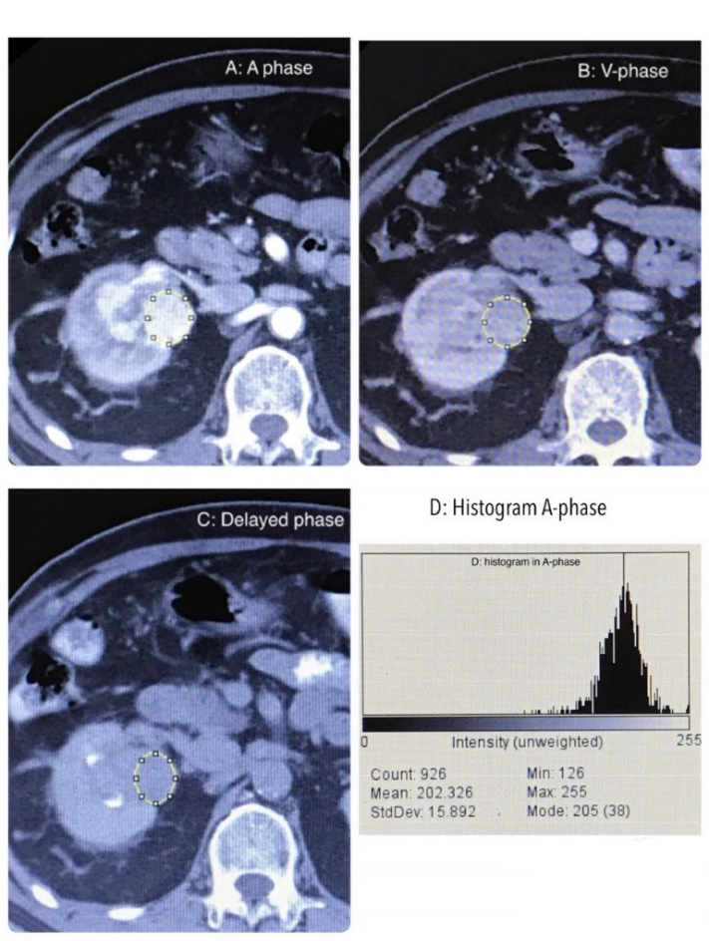

**Fig.1** Example of ROIs placement in the same patient with different phases (A: arterial, B: venous and C: Delayed phases). D showing histogram from ROI in A phase.

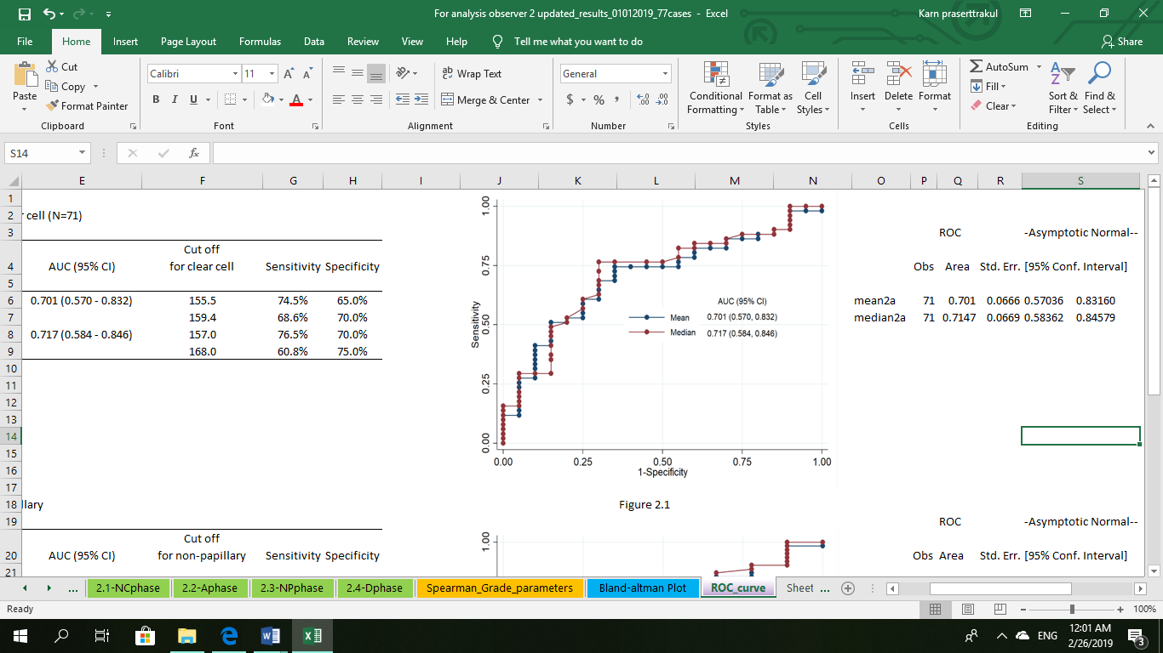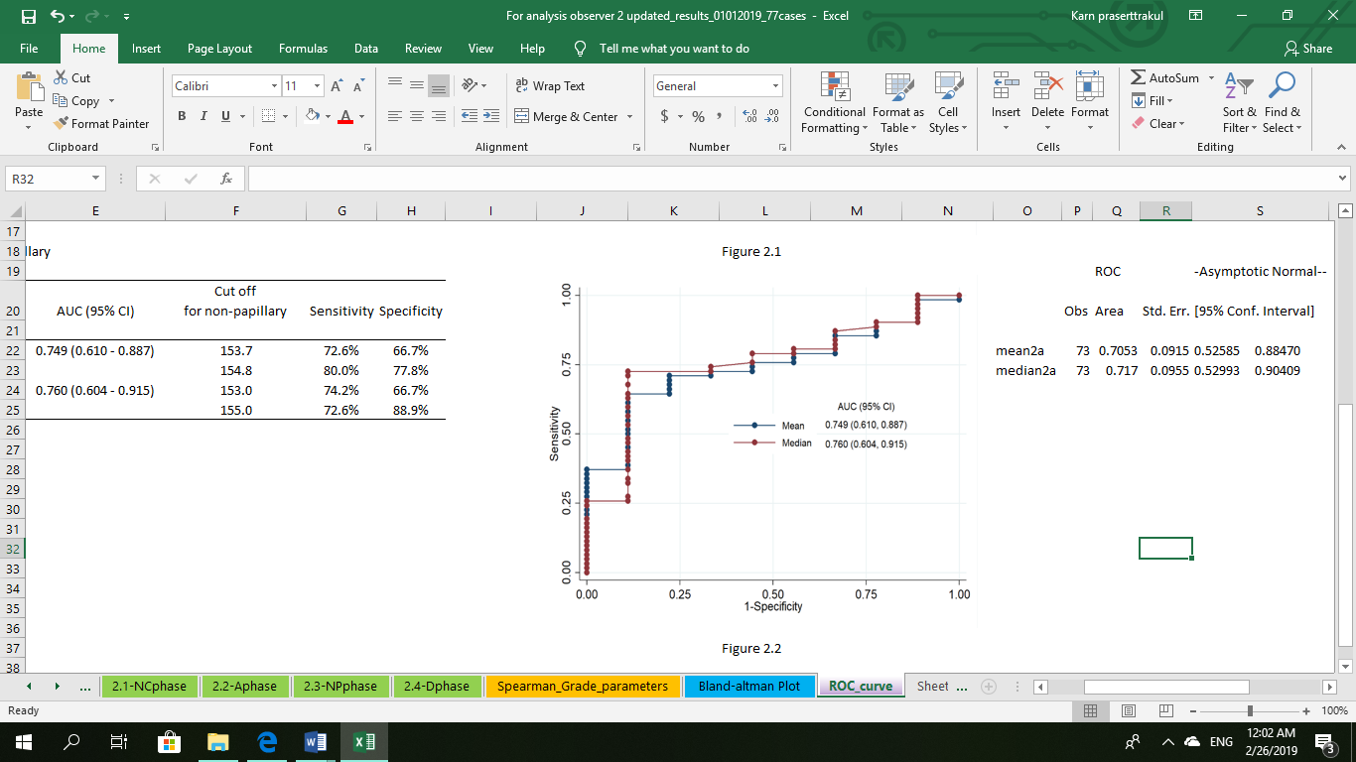

**Fig. 2.1-2.2**: ROC curve comparing clear cell vs non-clear cell RCCs and papillary vs non-papillary RCCs based on mean and median pixel attenuation on arterial phase.

|  |  |
| --- | --- |
| **Table 1: demographic and clinical characteristics of the patients** | N=77 |
|  |  |
| Characteristics | n (%) |
| **Sex** |  |
| Female | 19 (24.7) |
| Male | 58 (75.3) |
| **Age**, mean (SD, min-max) | 60 (15, 21-89) |
| **RK/LK** |  |
| Left | 36 (46.8) |
| Right | 41 (53.2) |
| **Size** (cm), median (IQR, min-max) | 5 (3.2 - 8.1, 1.2 - 21.1) |
| **RCC subtypes** |  |
| Clear cell | 54 (70.1) |
| Papillary | 10 (13) |
| Type I | 4 |
| Type II | 4 |
| N/A | 2 |
| Chromophobe | 4 (5.2) |
| Others | 9 (11.7) |
| Acquired cystic disease associated RCC | 1 (1.3) |
| Unclassified | 8 (10.4) |
| **ISUP nuclear grade** |  |
| Grade 1 | 8 (10.4) |
| Grade 2 | 37 (48.1) |
| Grade 3 | 22 (28.6) |
| Grade 4 | 4 (5.2) |
| N/A | 6 (7.8) |

|  |  |  |  |  |  |  |
| --- | --- | --- | --- | --- | --- | --- |
| **Table 2.1**  **Histogram parameters for arterial phase** | | | |  |  |  |
|  | | | | | | |
|  | **RCC subtypes** | | | |  |  |
| **parameters** | Clear cell  (N=51) | Papillary  (N=9) | Chromophobe  (N=3) | Others or mixed  (N=8) | Overall  (N=71) | p-value* |
| Mean | 169.1 (152.6, 199.1) | 136.7 (153.7, 100) | 137.8 (134.2, 169) | 160.3 (146.7, 180.2) | 166.4 (145.3, 185.8) | 0.036 |
| Median | 171 (157, 201) | 136 (154, 106) | 137 (136, 169) | 161 (147.5, 182.5) | 168 (150, 194) | 0.023 |
| SD | 17 (13.9, 21.6) | 9.9 (21.7, 7) | 10.9 (9.7, 16.1) | 18 (13.8, 21.7) | 16.9 (12.4, 21.6) | 0.166 |
| Kurtosis | 0.2 (-0.1, 1.23) | -0.15 (0.61, -0.42) | 1.09 (-0.33, 4.02) | 0.3 (-0.08, 1.23) | 0.37 (-0.14, 1.18) | 0.963 |
| Skewness | -0.25 (-0.61, 0.06) | -0.2 (0.48, -1.45) | 0.03 (-0.83, 0.96) | -0.23 (-0.86, 0.01) | -0.18 (-0.62, 0.07) | 0.340 |
| Values in cell is median (IQR) | |  |  |  |  |  |
| *P-value for comparison among groups using Kruskal-Wallis H test | | | |  |  |  |

|  |  |  |  |  |  |  |
| --- | --- | --- | --- | --- | --- | --- |
| **Table 2.2**  **Histogram parameters for nephrographic phase** | | | |  |  |  |
|  | | | | | | |
|  | **RCC subtypes** | | | |  |  |
| **parameters** | Clear cell  (N=54) | Papillary  (N=9) | Chromophobe  (N=3) | Others or mixed  (N=9) | Overall  (N=75) | p-value* |
| Mean | 169.1 (152.2, 178.9) | 135.4 (169.3, 128.1) | 150 (139.1, 180.8) | 151.8 (143.3, 159.6) | 162.4 (145.1, 177.7) | 0.199 |
| Median | 169 (152, 179) | 135 (168, 127) | 150 (139, 180) | 151 (145, 162) | 163 (148, 177) | 0.156 |
| SD | 13.6 (10.2, 16.8) | 10.1 (19.4, 6.5) | 10.3 (7.8, 13.2) | 17.1 (12.4, 19.6) | 13.3 (10.1, 17.5) | 0.444 |
| Kurtosis | 0.26 (-0.11, 1.44) | -0.01 (1.03, -0.36) | 0.38 (-0.05, 0.41) | 0.17 (-0.16, 0.28) | 0.25 (-0.11, 1.25) | 0.939 |
| Skewness | -0.14 (-0.58, 0.06) | 0.01 (0.3, -2.01) | 0.11 (0.03, 0.23) | -0.12 (-0.65, 0.11) | -0.12 (-0.58, 0.09) | 0.045 |
| Values in cell is median (IQR) | |  |  |  |  |  |
| *P-value for comparison among groups using Kruskal-Wallis H test | | | |  |  |  |

|  |  |  |  |
| --- | --- | --- | --- |
| **Table 3:** Spearman's correlation between histogram parameters and nuclear grade | | | |
|  |  |  |  |
| Phase | Parameters | Spearman's rho | p-value |
| NC Phase (N=71) |  |  |  |
|  | Mean | -0.227 | 0.057 |
|  | Median | -0.238 | 0.046 |
|  | SD | 0.045 | 0.712 |
|  | Kurtosis | 0.270 | 0.023 |
|  | Skewness | -0.059 | 0.625 |
| A Phase (N=65) |  |  |  |
|  | Mean | -0.209 | 0.094 |
|  | Median | -0.199 | 0.112 |
|  | SD | 0.000 | 0.999 |
|  | Kurtosis | 0.020 | 0.873 |
|  | Skewness | -0.092 | 0.465 |
| NP Phase (N=65) |  |  |  |
|  | Mean | -0.150 | 0.219 |
|  | Median | -0.170 | 0.162 |
|  | SD | 0.046 | 0.705 |
|  | Kurtosis | -0.013 | 0.915 |
|  | Skewness | 0.126 | 0.301 |
| D Phase (N=65) |  |  |  |
|  | Mean | -0.193 | 0.143 |
|  | Median | -0.191 | 0.147 |
|  | SD | 0.003 | 0.984 |
|  | Kurtosis | -0.044 | 0.739 |
|  | Skewness | 0.026 | 0.848 |

**REFERENCES**

1. Holger Moch, Antonio L. Cubilla, Peter A. Humphrey, Victor E. Reuter, et al. The 2016 WHO Classification of Tumours of the Urinary System and Male Genital Organs—Part A: Renal, Penile, and Testicular Tumours. Eur Urol 2016; 70:93–105

2. Srigley JR, Delahunt B, Eble JN, Egevad L, Epstein JI, Grignon D, et al. The international society of urological pathology (ISUP) vancouver classification of renal neoplasia. Am J Surg Pathol 2013;37(10):1469–89

3. Minnillo BJ, Zhu H, Maurice MJ, Abouassaly R. Trends in cytoreductive nephrectomy in the eras of immuno and targeted therapy. J Clin Oncol 2014 32:1–2

4. Vera-Badillo FE, Templeton AJ, Duran I, et al. Systemic therapy for non-clear cell renal cell carcinomas: a systematic review and meta-analysis. Eur Urol 2015; 67:740–749

5. Kunkle DA, Egleston BL, Uzzo RG Excise, ablate or observe: the small renal mass dilemma-a meta-analysis and review. J Urol 2008; 179:1227–1233

6. Abel EJ, Culp SH, Matin SF, et al. Percutaneous biopsy of primary tumor in metastatic renal cell carcinoma to predict high risk pathological features: comparison with nephrectomy assessment. J Urol 2010; 184:1877–1881

# 7. Kim JK, [Kim TK](https://www.ncbi.nlm.nih.gov/pubmed/?term=Kim%20TK%5BAuthor%5D&cauthor=true&cauthor_uid=12034628), [Ahn HJ](https://www.ncbi.nlm.nih.gov/pubmed/?term=Ahn%20HJ%5BAuthor%5D&cauthor=true&cauthor_uid=12034628), et al. Differentiation of subtypes of renal cell carcinoma on helical CT scans. [AJR Am J Roentgenol.](https://www.ncbi.nlm.nih.gov/pubmed/12034628) 2002; 178(6):1499-506

8. Bae KT, Fuangtharnthip P, Prasad SR. Joe BN, Heiken JP. Adrenal masses: CT characterization with histogram analysis method. Radiology 2003; 228: 735-742

# 9. [Kim JY](https://www.ncbi.nlm.nih.gov/pubmed/?term=Kim%20JY%5BAuthor%5D&cauthor=true&cauthor_uid=18094264), [Kim JK](https://www.ncbi.nlm.nih.gov/pubmed/?term=Kim%20JK%5BAuthor%5D&cauthor=true&cauthor_uid=18094264), [Kim N](https://www.ncbi.nlm.nih.gov/pubmed/?term=Kim%20N%5BAuthor%5D&cauthor=true&cauthor_uid=18094264), [Cho KS](https://www.ncbi.nlm.nih.gov/pubmed/?term=Cho%20KS%5BAuthor%5D&cauthor=true&cauthor_uid=18094264). CT histogram analysis: differentiation of angiomyolipoma without visible fat from renal cell carcinoma at CT imaging. Radiology 2008; 246(2):472-9

10. [Lubner MG](https://www-ncbi-nlm-nih-gov.cuml1.md.chula.ac.th/pubmed/?term=Lubner%20MG%5BAuthor%5D&cauthor=true&cauthor_uid=27145377), [Stabo N](https://www-ncbi-nlm-nih-gov.cuml1.md.chula.ac.th/pubmed/?term=Stabo%20N%5BAuthor%5D&cauthor=true&cauthor_uid=27145377), [Abel EJ](https://www-ncbi-nlm-nih-gov.cuml1.md.chula.ac.th/pubmed/?term=Abel%20EJ%5BAuthor%5D&cauthor=true&cauthor_uid=27145377), [Del Rio AM](https://www-ncbi-nlm-nih-gov.cuml1.md.chula.ac.th/pubmed/?term=Del%20Rio%20AM%5BAuthor%5D&cauthor=true&cauthor_uid=27145377), [Pickhardt PJ](https://www-ncbi-nlm-nih-gov.cuml1.md.chula.ac.th/pubmed/?term=Pickhardt%20PJ%5BAuthor%5D&cauthor=true&cauthor_uid=27145377). CT Textural Analysis of Large Primary Renal Cell Carcinomas: Pretreatment Tumor Heterogeneity Correlates with Histologic Findings and Clinical Outcomes. [AJR Am J Roentgenol.](https://www-ncbi-nlm-nih-gov.cuml1.md.chula.ac.th/pubmed/?term=CT+Textural+Analysis+of+Large+Primary+Renal+Cell+Carcinomas%3A+Pretreatment+Tumor+Heterogeneity+Correlates+with+Histologic+Findings+and+Clinical+Outcomes) 2016; 207(1):96-105

11. Chen F, Huhdanpaa H, Desai B, Hwang D, Cen S, Sherrod A et al. Whole lesion quantitative CT evaluation of renal cell carcinoma: differentiation of clear cell from papillary renal cell carcinoma. SpringerPlus. 2015;4(1)