**Transorbital, A 1.6 cm. glass marble ball in the maxillary sinus**

**Abstract**

Foreign bodies in the sinus are not common and transorbital foreign bodies in the maxillary sinus are very rare. We described a case of a glass marble ball about 1.6 cm. in diameter penetrated into the right maxillary sinus through the orbital floor without globe rupture. The foreign body in the sinus should be removed to prevent further infection and other complications. In this case, the glass marble ball was removed by transnasal endoscopic technique with widened maxillary antrum after guarding of orbital ball upward in order to prevent the orbital injury. No immediate and long term postoperative complications.

**Introduction**

Presence of foreign bodies in the maxillary sinus is uncommon. Most of those foreign bodies caused by dental origin such as tooth (1). Transorbital maxillary sinus foreign bodies are rare. For removal of foreign body in maxillary sinus, there are two main surgical approaches; external and endoscopic sinus surgery. We describe an unusual case of a glass marble ball penetrated into the maxillary sinus through the orbital floor. The presentation of patient and the surgical technique are described.

**Case Description**

A 13-year old, male patient visited the hospital for an injury on his right eye. The right eye was hit by a glass marble ball. The patient was admitted by an ophthalmologist. He was diagnosed as orbital trauma with severe chemosis without globe ruptured and received supportive treatment with local eye care and pain killer for two days. The pain of his right eye and cheek still persisted; therefore, skull x-ray was done to evaluate the extent of eye injury (Fig.1). The round shape foreign body was found in the right maxillary sinus. Then, otolaryngologist was consulted for foreign body removal.

The examination revealed swelling of upper and lower eyelid with total hyphema and marked chemosis of the right eye (Fig.2). His right eye vision was light perception. Nasal endoscopic findings were minimal bloody discharge from right middle meatus and swelling nasal mucosa. CT scan of paranasal sinuses showed a round shape foreign body about 1.6 cm. in diameter and fracture at floor of right orbit. Swelling of right optic nerve was also noted (Fig.3).

**Surgical Procedure**

Removal of glass marble ball from right maxillary sinus was performed under general anesthesia transnasal endoscopic technique. Uncinectomy was done and the maxillary ostium was widened using microdebrider. The bony of floor orbit was broken and fallen to obstruct the maxillary antrum. Right subciliary incision was done and then the right eyeball was retracted the upward (Fig.4). The size of defect of the orbital floor was 1.63 cm. The glass marble ball was removed via the widened maxillary antrum using the aid of a curved suction (Fig.5). The orbital floor defect was reconstructed using titanium mesh.

**Follow-up**

Postoperatively, the patient was treated with antibiotics and eye care. The nasal endoscopic examination was performed one week after the operation. The visual acuity was turned to no light perception. The chemosis was resolved within two weeks. No immediate and long term complications from surgical removal.

**Discussion**

Foreign bodies in maxillary sinus are uncommon. Transorbital maxillary sinus foreign bodies are very rare. There are only few cases reported before. First was a 30 years old male patient with a broken handle of scooter lodged in the right maxillary sinus(2). It was penetrated through the orbital floor without any injury to the globe and it was removed via buccal sulcus approach. Second case was a 60 years old male patient with a broken pen, 20 years after trauma, lodged in the left maxillary sinus causing ectropian of left lower eyelid(3). The pen was removed via subciliary incision.

In this case report, the glass marble ball size 1.6 cm in diameter was found in the skull x-ray at the floor of maxillary sinus. Screening CT scan of paranasal sinuses provided the extent of injury and the anatomical defects from the injury. The choices for removal the foreign body in maxillary sinus are open surgery via a Caldwell Luc approach and functional endoscopic sinus surgery or combination(4). Nowadays, the most common procedure is functional endoscopic approach (5, 6). The advantages of endoscopic approach include its less invasive, a short recovery time and decrease risk of infraorbital nerve injury(7).

We found that the fractured floor orbit and the orbital fat were fallen to obstruct the maxillary ostrium. Therefore, we could not access through middle meatal antrostomy. We had to combine open approach via subciliary incision with nasal endoscopic approach for removal the glass marble ball. The guarding of orbital ball should be performed before maxillary approach in order to prevent the orbital injury.

Even if the glass marble ball could be removed via the defected site at orbital floor, we desired to widen the maxillary ostium in order to prevent osteomeatal complex (OMU) obstruction from fallen orbital floor. Another advantage of maxillary antrostomy is post-operative sinus drainage care.

This case is interesting because the route of entry of the foreign body. Then, the foreign body was removed via endoscopic sinus surgery.

**Conclusion**

A non-dental origin foreign body in maxillary sinus is uncommon. The foreign body in the sinus should be removed to prevent further infection and other complications. CT scan of paranasal sinuses should be performed for surgical planning. Nowadays, endoscopic approach is the first line of surgical approach. Open approach is necessary in some cases such as very large foreign body or the fallen of orbit obstructs the natural opening of the sinus.

**Acknowledgement**

The author would like to thank Assoc. Prof. Dr. Supinda Chusakul for comments that greatly improved this manuscript.

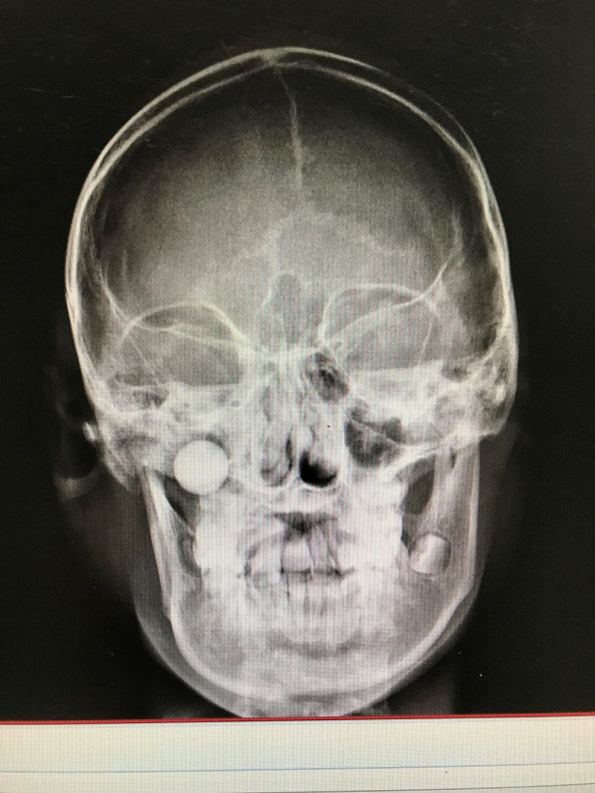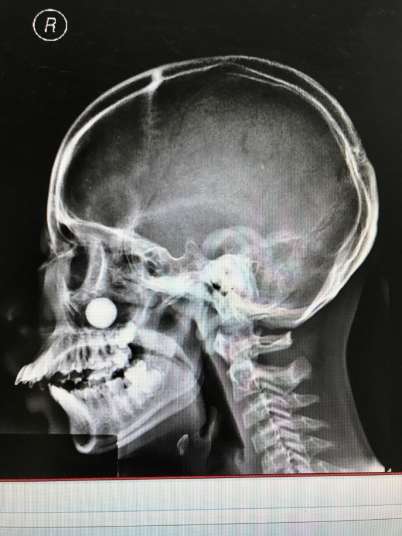

Fig.1



Fig.2

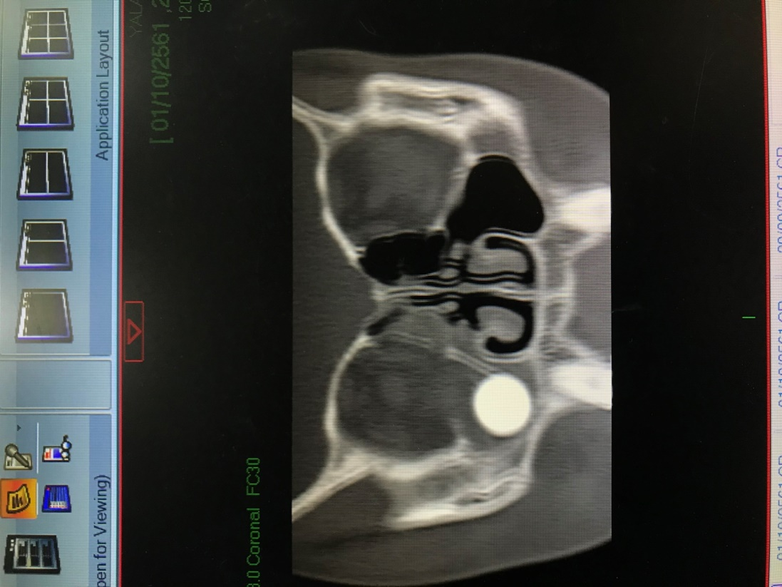

Fig.3

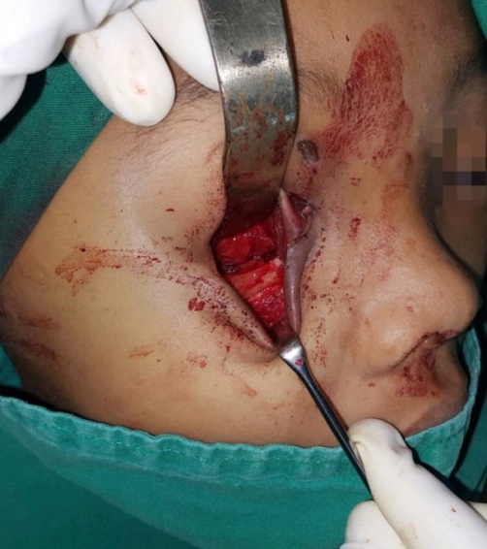

Fig.4

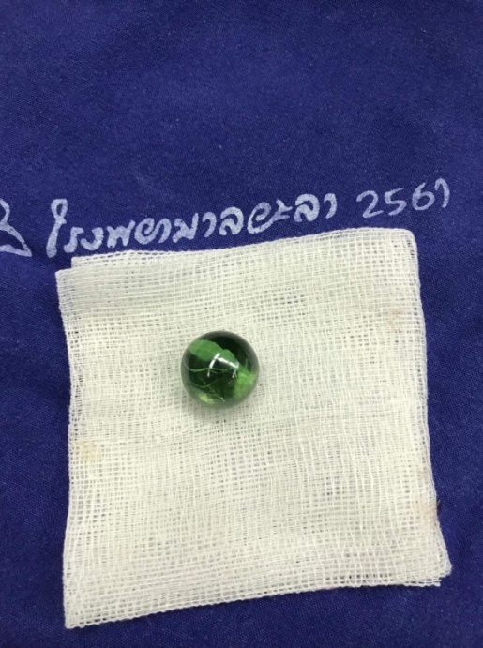

Fig.5

**References**

1. Oinam B, Ningombam J, Puyam S, Thingbaijam S. The role of endoscopic sinus surgery in maxillary sinus foreign body removal. Journal of Medical Society 2016;30:61-3.

2. Jagannathan M, Nayak BB, Baliarsing AS, Babu ND. An unusual case of orbital trauma with a large foreign body in the maxilla. British Journal of Plastic Surgery 1999;52:507-8.

3. Mangwani J, Su AP. Late presentation of a paranasal sinus glass foreign body: a case report. Cases J 2009;2:6483.

4. Friedlich JaRBN. Endoscopic Assisted Caldwell-Luc Procedure for Removal of a Foreign Body from the Maxillary Sinus. Journal of the Canadian Dental Association 2005;71:200-1.

5. Costa F, Robiony M, Toro C, Sembronio S, Politi M. Endoscopically assisted procedure for removal of a foreign body from the maxillary sinus and contemporary endodontic surgical treatment of the tooth. Head Face Med 2006;2:37.

6. Chandrasena F, Singh A, Visavadia BG. Removal of a root from the maxillary sinus using functional endoscopic sinus surgery. British Journal of Oral and Maxillofacial Surgery 2010;48:558-9.

7. R.V.Nataraj MJ. An unusual maxillary sinus foreign body and Its Endoscopic Assisted Removal. International Journal of Otolaryngology and Head & Neck Surgery 2015;4:38-43.